Multi-objective Optimization Design of Marine Structures Based on An Enhanced Starfish Algorithm
Thanh Do-Quang¹, T. Vu-Huu¹, Thanh Cuong-Le^{2,*}
¹Faculty of Civil Engineering, Vietnam Maritime University, 484 Lach Tray Str., Hai Phong, Vietnam, 180000
²Center for Engineering Application & Technology Solutions, Ho Chi Minh City Open University, Ho Chi Minh City, Vietnam.
*Corresponding author: cuong.lt@ou.edu.vn

ABSTRACT:
Marine jetty design is a constrained trade-off problem. Reducing pile size, pile length, or construction cost may lower material demand, but it can also increase displacement and local force demand under berthing, mooring, and service loads; the opposite choice shifts the compromise in the other direction. This design setting motivates two multi-objective versions of the Starfish Optimization Algorithm (SFOA): the base multi-objective SFOA (B-MOSFOA) and the enhanced multi-objective SFOA (E-MOSFOA). B-MOSFOA adapts the single-objective SFOA by adding a Pareto archive, grid-based diversity control, and leader selection from the archive. E-MOSFOA maintains this external archive while altering search dynamics via cosine-phase control, leader-guided mutation, and late-stage refinement. Evaluation is carried out on the IMOP, UF, and RM-MEDA benchmark suites using convergence and diversity indicators, rank summaries, and two-sided Wilcoxon rank-sum tests with Holm adjustment across 30 independent runs per problem. The Multi-objective Mantis Search Algorithm (MOMSA), Non-dominated Sorting Moth-Flame Optimization (NS-MFO), and Multi-objective Generalized Normal Distribution Optimization (MOGNDO) serve as published comparators under common population, archive, iteration, and run-count settings. However, their native procedures retain different totals for function evaluation. No method is best in every case: MOMSA gives the lowest overall average rank (2.52), followed by E-MOSFOA (2.58) and B-MOSFOA (2.75), while B-MOSFOA performs best on IMOP by average rank (2.28). The engineering study then applies the framework to a liquid-bulk marine jetty comprising a berthing dolphin, a mooring dolphin, and a main jetty platform, with MATLAB coordinating the design variables and SAP2000 evaluating each candidate. The greatest simultaneous improvement occurs for the mooring dolphin, where the least-cost Pareto design reduces cost by 81.5% and maximum displacement by 42.4% relative to the current design. All six final archives satisfy the implemented strength, geotechnical, and geometric constraints, with a maximum pile-utilization ratio of 0.9971.
KEYWORDS: Multi-objective optimization; Starfish Optimization Algorithm; Marine jetty structures; Finite element model; Pareto dominance; Adaptive mutation; Phase control.
  - Introduction
Port-structure design, particularly for pile-supported marine jetties, usually involves several competing requirements rather than a single governing criterion. Selecting shorter or smaller piles may reduce construction costs. Still, it can also increase deck displacement, pile bending moment, pile shear force, pile axial force, or the risk that the pile tip is located in an unsuitable soil layer. In a pile-supported jetty, these checks are not separate. A change in pile diameter or embedment length alters the response of the deck, beams, and pile group under permanent load, live load, berthing impact, and mooring action; the same layout must then pass the relevant port-structure and pile-foundation checks. Therefore, design guidance for actions such as berthing and mooring loads, pile-foundation resistance, and marine structural detailing is commonly drawn from PIANC [1], OCDI [2], TCVN 7888:2014 [3], and TCVN 10304:2014 [4]. For this reason, marine jetty design is formulated as a set of feasible trade-offs rather than as a single prescribed optimum.
Multi-objective optimization is suitable for this design problem because the alternatives must be assessed against several competing criteria rather than a single, fixed weighted sum objective. Pareto dominance provides a more appropriate basis for comparing such alternatives. The concepts of the Pareto set, Pareto front ($PF$), and dominance relation describe situations in which an improvement in one objective may require a compromise in another [5-7]. In the present engineering context, cost, displacement, member forces, and pile-foundation performance do not normally vary in the same direction. The multi-objective optimization formulation is therefore well-suited to structural optimization, where each candidate design is evaluated using the analysis model. At the same time, serviceability, strength, and geotechnical foundation constraints are considered simultaneously [8].
Population-based metaheuristics are widely used for nonlinear and high-dimensional structural problems because they can search without gradient information and can work with black-box finite-element models (FEM) [9-12]. Recent multi-objective algorithms illustrate different ways to preserve convergence and diversity. NS-MFO combines moth-flame search with non-dominated sorting and includes benchmark and engineering assessments [13]. MOMSA combines mantis search with elitist non-dominated sorting and crowding distance; its original evaluation covers 20 benchmark problems, nine engineering design problems, and optimal-power-flow cases [14]. MOGNDO uses an external archive, grid-based diversity control, and archive-guided leader selection, with reported evaluations across 35 mathematical and engineering cases [9]. Differential Evolution also remains an important reference for mutation and crossover in population-based search [15]. Together, these studies show that archive management, leader selection, sorting strategy, and variation operators strongly affect the quality of $PF$ approximation.
SFOA [16] was originally developed as a single-objective method based on starfish-inspired search behavior. Its direct application to the present marine structural design problem is limited because it lacks several components needed to handle competing objectives, including a repository of non-dominated solutions, a mechanism to maintain a well-spread Pareto front, and a rule for selecting search leaders from high-quality candidates. For this reason, two modified versions are considered. B-MOSFOA establishes the basic multi-objective structure by incorporating Pareto dominance, an external archive, grid-based diversity management, and archive-derived leader selection. E-MOSFOA is subsequently built on this version by introducing Latin hypercube sampling at the initialization stage, cosine-regulated search phases, leader-guided mutation, crossover, and an archive-based refinement procedure near the end of the optimization process.
Validation of the proposed algorithms should cover more than one problem family because no algorithm is uniformly best across all problem classes, as stated by the NFL theorem [17]. For this reason, this study uses the IMOP benchmark suite [18], the UF test suite from the CEC 2009 multi-objective competition [19], and the RM-MEDA test functions associated with the regularity model-based multi-objective estimation framework [20]; together, these suites provide different $PF$ geometries, decision-variable interactions, and scalability settings. Solution quality also cannot be summarized by a single indicator. Therefore, $IGD$, $ϵ$, $Δ$, and $MS$ are used to measure convergence accuracy, approximation quality, distribution uniformity, and diversity coverage from complementary perspectives [6, 21-24]. These metric values are further complemented by rank summaries and two-sided Wilcoxon rank-sum tests with Holm adjustment [25-28]. In other words, these benchmarks, indicators, rankings, and statistical testing choices provide a broader basis for evaluating whether the MOSFOA variants improve only isolated cases or remain competitive across different problem structures.
Overall, the study evaluates whether B-MOSFOA and E-MOSFOA provide a practical framework for constrained multi-objective optimization in marine-jetty design. At the benchmark level, IMOP, UF, and RM-MEDA are used to compare the two variants with MOMSA, NS-MFO, and MOGNDO under common population, archive, iteration, and run-count settings while retaining algorithm-specific function-evaluation totals; solution indicators, ranks, Wilcoxon-Holm tests, computational effort, and parameter sensitivity provide complementary evidence. At the engineering level, the coupled MATLAB-SAP2000 workflow minimizes construction cost and maximum displacement for the three jetty subsystems, while strength, geotechnical, and geometric requirements remain explicit constraints. The complete sequence, from methodological formulation to benchmarking and engineering assessment, is summarized in Figure A1. Section 2 describes the methods, Section 3 presents the benchmark study, Section 4 examines the engineering application, and Section 5 gives the conclusions, limitations, and future work.
  - Methodology
    - Foundations of Multi-objective Optimization
Multi-objective optimization addresses problems involving multiple conflicting objectives, where improving one criterion may degrade others [5, 29, 30]. The underlying efficiency concept traces to Edgeworth and Pareto [31, 32], while constraint-based formulations provide an alternative to reducing all objectives to a fixed weighted sum [33]. Unlike single-objective optimization, which seeks a unique optimum, multi-objective optimization aims to identify a set of trade-off solutions forming the $PS$ and the corresponding $PF$ [6]. A solution dominates another if it is no worse in all objectives and strictly better in at least one. Non-dominated solutions form the $PS$, while their mapping in objective space forms the $PF$ [7].
$$\underset{X}{Minimize}{F\left(X\right)}=\left\{f_{1}\left(X\right),f_{2}\left(X\right),…,f_{m}\left(X\right)\right\},$$ | (1)
where $X$ denotes the design vector, $f_{m}\left(X\right)$ is the $m$-th objective, and $m$ gives the number of objectives. The objectives are kept in vector form so that competing designs can be compared through Pareto dominance. This avoids assigning a fixed set of weights before the search, which could compress the design trade-offs into a single scalar objective.
A useful $PF$ is more than a set of points close to the optimum; it also needs enough spread for design comparison. This becomes difficult when the search space is nonlinear, discontinuous, or high-dimensional. In the jetty problem, a search that moves too strongly toward cost can fill the archive with similar low-cost layouts. A search that spreads too widely can, in turn, miss stiffer designs that are still affordable. The algorithm therefore keeps non-dominated designs in an external archive, selects leaders from less populated regions, and refines promising areas after the front becomes more stable. In this setting, B-MOSFOA provides an archive-based structure, while E-MOSFOA strengthens it through adaptive search and final-stage refinement.
    - Proposed B-MOSFOA
B-MOSFOA keeps the movement equations of SFOA [16] but changes the way a candidate is judged after its objective values are obtained. In the single-objective SFOA, a single fitness value suffices to identify the best current solution. In the present multi-objective problem, each design gives a vector of objective values, so the algorithm first checks Pareto dominance [5-7] and places the surviving designs in an external archive, consistent with established archive-based evolutionary approaches [34-36]. This archive is not treated as a simple list of good points. Following archive-based diversity control used in recent multi-objective metaheuristics [9], it is divided into grid cells in the objective space, and archive members from cells with fewer solutions are more likely to be used as leaders. As a result, isolated parts of the trade-off front can still guide the next step in the movement, rather than being lost behind dense groups of similar solutions.
The position-update step follows the original SFOA search behavior but is evaluated in a multi-objective setting. A probabilistic control parameter assigns each iteration to exploration or exploitation. In exploration, B-MOSFOA uses the arm-twist rule for high-dimensional updates and the energy-step rule for lower-dimensional movement. In exploitation, candidate positions are updated by the preying rule, and regeneration is applied to the last individual to refresh the population. Before objective evaluation, any out-of-bound coordinate is returned to its previous value, after which the complete candidate vector is projected onto the allowed variable interval.
$$Y_{i}=X_{i}​+a_{1}​\left(X_{leader}-X_{i}​\right)⋅\left\{\begin{matrix}\cos\left(θ\right), r≤0.5 \\ \sin\left(θ\right), r>0.5\end{matrix}\right.,$$ | (2)
$$Y_{i}=E{∙X}_{i}+A_{1}∙\left(X_{k_{1}}-X_{i}\right)+A_{2}∙\left(X_{k_{2}}-X_{i}\right),$$ | (3)
$$Y_{i}=X_{i}+r_{1}d_{m1}+r_{2}d_{m2},$$ | (4)
$$d_{m}=X_{leader}-X_{m} \left(∀m=1,...,5\right),$$ | (5)
$$Y_{N}=e^{\left(-\frac{it×N}{Max_it} \right)}X_{N}.$$ | (6)
Eqs. (2)-(6) adapt the SFOA position-update rules [16] to the archive-guided multi-objective setting. Eqs. (2) and (3) construct exploratory trial positions, whereas Eqs. (4) and (5) move candidates with respect to neighboring individuals and the selected archive leader. Eq. (6) gives the regeneration rule for the last individual. In these equations, $X_{i}$ and $Y_{i}$ are the current and trial position vectors of candidate $i$; $X_{leader}$ is the selected archive leader; $X_{k1}$, $X_{k2}$, and $X_{m}$ are sampled population members; $a_{1}$, $E$, $A_{1}$, and $A_{2}$ are SFOA movement coefficients; $θ$ is the angular parameter; $r$, $r_{1}$, and $r_{2}$ are random numbers; $d_{m}$, $d_{m1}$ and $d_{m2}$ are direction vectors; $N$ is the population size; and $it$/$Max_it$ indicates the progress of the current run.
After the new population is evaluated, its non-dominated members are combined with the current archive. Dominated archive members are removed. If the archive exceeds its prescribed capacity, crowding-distance truncation removes candidates from dense parts of the front before the adaptive grid is rebuilt. Cell occupancy then determines the leader-selection probability in Eq. (7); sparsely populated cells receive larger probabilities and therefore contribute more often as search leaders.
$$P_{i}=\frac{c}{N_{i}},$$ | (7)
where $N_{i}$ is the occupancy of grid cell $i$, $c$ is a normalization constant, and $P_{i}$ is the probability of selecting a member from that cell. The inverse-density relation gives sparsely populated cells a larger selection probability.
    - Proposed E-MOSFOA
E-MOSFOA builds on the SFOA movement logic [16] and the Pareto-archive structure used in B-MOSFOA [5-7]. It introduces adaptive mechanisms to improve convergence and solution distribution while maintaining low computational cost. First, Latin hypercube sampling [37] generates the initial population within the prescribed decision bounds and provides stratified coverage of each decision dimension. Then, a cosine-based schedule replaces the fixed exploration probability, decreases smoothly to zero, emphasizes early global exploration, and gradually shifts effort toward exploitation.
$$GP=\frac{GP_{0}}{2}\left(1+cos\left(π∙\frac{it}{Max_it} \right)\right)$$ | (8)
Eq. (8) decreases the exploration probability $GP$ smoothly from $GP_{0}$ to zero as $it$ approaches $Max_it$, thereby avoiding an abrupt switch between exploration and exploitation.
During exploration, E-MOSFOA supplements the SFOA movement with leader-guided Differential Evolution mutation and binomial crossover [15], as defined in Eqs. (9)-(11). During exploitation, a separate Gaussian perturbation is activated with probability 0.1 and uses 1% of each decision-variable range as its standard-deviation scale. All trial vectors are projected onto the prescribed bounds before objective evaluation.
$${mutant}_{i}=X_{r1}+F∙\left(X_{r2}-X_{r3}\right)+λ∙\left(X_{leader}-X_{r1}\right),$$ | (9)
$$F=0.5\left(1-\frac{it}{Max_it}\right),$$ | (10)
$$Y_{i,j}=\left\{\begin{matrix}{mutant}_{i,j}, & r_{i,j}<CR, \\ X_{i,j}, & \text{otherwise},\end{matrix}\right. CR=0.5$$ | (11)
Eq. (9) combines the Differential Evolution difference vector with attraction toward $X_{leader}$. In this expression, $X_{r1}$, $X_{r2}$, and $X_{r3}$ are distinct sampled population members, mutanti is the trial mutation vector, $F$ is the mutation scale, and $λ=0.3$ is the leader-attraction coefficient. Eq. (10) decreases $F$ from 0.5 to zero. Eq. (11) gives componentwise binomial crossover, where $j$ indexes decision variables and $r_{i,j}∼U\left(0,1\right)$; the mutant coordinate is selected when $r_{i,j}<CR$, with $CR=0.5$.
For local intensification, the algorithm selects an archive reference member using the unweighted sum of objective values. During the final 20% of iterations, Gaussian perturbation regenerates 10% of the population around this reference member. Importantly, the reference member serves only as a local-search center; Pareto dominance and the external archive still govern final solution retention.
$$X^{*}=argmin\left(\sum_{j=1}^{M}{f_{i,j} }\right)$$ | (12)
$$Y_{i}=X^{*}+σ∙N(0,σ^{2})$$ | (13)
Eq. (12) selects the archive reference member used as the local-search center in the archive-guided refinement step [9]. Here, $X^{*}$ is the selected reference member, $k$ indexes archive members, $i$ indexes objectives, and $f_{k,i}$ is the value of objective $i$ for archive member $k$. Eq. (13) generates late-stage trial points through Gaussian perturbation, where $σ$ is the scale and $N\left(0,σ^{2}\right)$ denotes a zero-mean normal random vector. The reference member does not replace Pareto dominance [5-7] as the final retention rule.
- Pseudo-code of B-MOSFOA and E-MOSFOA
Input:
Objective vector $F\left(X\right)=\left\{f_{1}\left(X\right), ..., f_{M}\left(X\right)\right\}$, penalty term $P\left(X\right)$ from Eq. (23),
bounds $\left[l_{b}, u_{b}\right]$, population size $N$, maximum iteration $Max_it$,
archive capacity $N_{r}$, grid size $n_{grid}$, and initial exploration probability $GP_{0}$.
Output:
Final external archive $A$ of retained non-dominated designs.
Initialize population Pop=${\left\{X_{i}\right\}}_{i=1}^{N}$ within $\left[l_{b}, u_{b}\right]$.
B-MOSFOA: use uniform random sampling.
E-MOSFOA: use Latin hypercube sampling.
Evaluate $F\left(X_{i}\right)$ and $P\left(X_{i}\right)$ for all $X_{i}∈$ Pop.
Initialize archive $A$ after constraint handling and Pareto dominance.
Build adaptive-grid and crowding-distance structures for archive $A$.
for $it=1$ to $Max_it$ do
Set the exploration probability $GP$.
B-MOSFOA: set $GP=GP_{0}$ as in the basic SFOA setting.
E-MOSFOA: update $GP$ by the cosine phase-control rule in Eq. (8).
Select $X_{leader}$ from a sparse grid/crowding region of $A$.
for each candidate $X_{i}∈$ Pop do
if rand < $GP$ then
Generate trial vector $Y_{i}$ using the SFOA exploration rules in Eqs. (2)-(3).
if E-MOSFOA is used then
Form mutant_{i} and update Y_{i} by leader-guided mutation and binomial crossover
using Eqs. (9)-(11).
end if
else
Generate trial vector $Y_{i}$ using the SFOA exploitation rules in Eqs. (4)-(6).
if E-MOSFOA is used then
Apply adaptive Gaussian perturbation when activated.
end if
end if
Apply boundary handling.
end for
Evaluate $F(X_{i})$ and $P\left(X_{i}\right)$ for the updated Pop.
Merge Pop with $A$ and update $A$ by constraint handling, Pareto dominance,
crowding-distance truncation, and adaptive-grid indexing using Eq. (7).
if E-MOSFOA is used and $it≥0.8Max_it$ then
Select archive reference member $X^{*}$ by Eq. (12).
Refined candidates by Eq. (13).
Project refined candidates to $\left[l_{b}, u_{b}\right]$, evaluate them, and update $A$.
end if
end for
return $A$
Algorithm 1 summarizes the complete workflow of B-MOSFOA and E-MOSFOA, including population initialization, archive update, leader selection, movement updates, and additional adaptive operators used in E-MOSFOA. Fig. 1 provides a visual representation of this procedure and clarifies how the main optimization loop, archive operations, and E-MOSFOA-specific refinement steps are connected during execution.
The computational order of both variants is governed mainly by population update, objective evaluation, archive updating, dominance checking, and archive truncation. For a population of size $N$, decision dimension $D$, objective dimension $M$, and archive capacity $N_{r}$, and objective-evaluation cost $C_{f}$, the dominant operations are $O(ND)$, $O(NC_{f})$, $O\left(\left(N+N_{r}\right)2M\right)$, and $O\left(MN_{r}\log{N_{r}}\right)$, respectively. The adaptive operators introduced in E-MOSFOA add only linear population-level operations per iteration and do not change the asymptotic order relative to B-MOSFOA. Practical runtime is therefore reported separately in the benchmark section because it also depends on the objective-function implementation and computing environment.
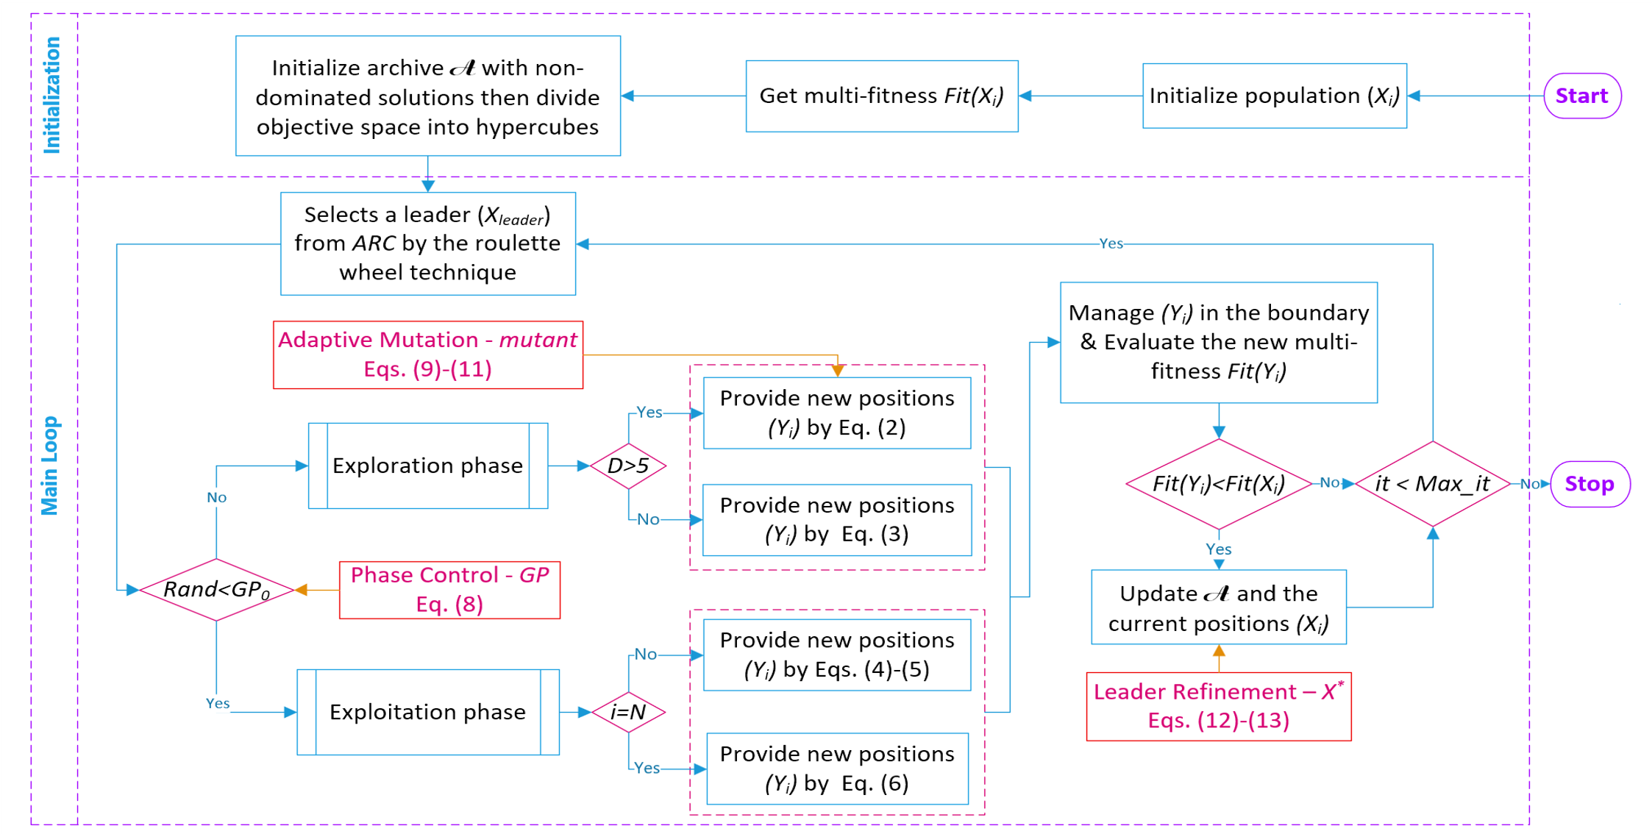
        - Algorithmic workflow of the proposed B-MOSFOA and E-MOSFOA.
  - Experimental Setup and Benchmark Results
    - Benchmark Suites and Performance Metrics
The benchmark evaluation is based on three established test suites: IMOP [18], UF [19], and RM-MEDA [20]. These suites include two- and three-objective problems, 10- and 30-dimensional decision spaces, and several Pareto-front geometries and variable-coupling patterns. The selected problems, therefore, provide complementary conditions for assessing convergence, distribution, and the preservation of diversity. Table 1 summarizes the objective dimension, decision-variable dimension, search range, and reference source for each benchmark group.
- Benchmark suites.
Problems | No. of objectives $(M)$ | No. of variables $\left(D\right)$ | Range | Ref.
IMOP1-3 | 2 | 30 | $x_{i}∈\left[0,1\right]$ | [18]
IMOP4-8 | 3 | 10 | $x_{i}∈\left[0,1\right]$ | [18]
UF1,2 | 2 | 30 | $x_{i}∈\left[-1,1\right]$ | [19]
UF3 | 2 | 30 | $x_{i}∈\left[0,1\right]$ | [19]
UF4 | 2 | 30 | $x_{1}∈\left[0,1\right]$&$x_{i=2..D}∈\left[-2,2\right]$ | [19]
UF5-7 | 2 | 30 | $x_{1}∈\left[0,1\right]$&$x_{i=2..D}∈\left[-1,1\right]$ | [19]
UF8-9 | 3 | 30 | $x_{1,2}∈\left[0,1\right]$&$x_{i=3..D}∈\left[-2,2\right]$ | [19]
RM-MEDA-P1,2,3,5,6,7 | 2 | 10 | $\begin{matrix}x_{1}∈\left[0,1\right]\end{matrix}$ | [20]
RM-MEDA-P9 | 2 | 10 | $\begin{matrix}x_{1}∈\left[0,1\right]\end{matrix}$&$x_{i=2..D}∈\left[0,10\right]$ | [20]
RM-MEDA-P4,8 | 3 | 10 | $\begin{matrix}x_{1}∈\left[0,1\right]\end{matrix}$ | [20]
Four indicators are used because a single metric cannot describe all aspects of a $PF$ approximation. $IGD$ [21] and $ε$ [22] mainly reflect convergence or approximation accuracy, $Δ$ [6] describes distribution uniformity, and $MS$ [6] describes the covered extent of the front. The preferred direction is reported in Table 2: $IGD$, $ε$, $Δ$ are minimized, while $MS$ is maximized. These metric directions are used consistently in all ranks, statistical comparisons, and summary counts.
A common experimental protocol is used for all benchmark comparisons. The comparator set consists of NS-MFO [13], MOMSA [14], and MOGNDO [9], which represent non-dominated sorting, elitist crowding-distance sorting, and archive-grid leader selection, respectively. All algorithms use the same problem definitions, a population size of 100, a maximum number of iterations of 500, and 30 independent runs per problem. Algorithms with external archives use an archive capacity of 200. For both B-MOSFOA and E-MOSFOA, $N_{r}=200$, $n_{grid}=10$; and $GP_{0}=0.5$. These settings form the main benchmark baseline, and their sensitivity is examined separately.
- Performance metrics.
Metric | Measures | Purpose | Preferred Value | Ref.
$ε$ | Minimum shift to dominate the reference front | Convergence | Low | [22]
$IGD$ | Average distance from the reference front to the approximation | Convergence and Diversity | Low | [21]
$Δ$ | Uniform spacing between consecutive solutions | Distribution | Low | [38]
$MS$ | Maximum extent covered in objective space | Diversity | High | [38]
For each problem and indicator, Best, Mean, and Std are obtained from the 30 independent runs. Mean values are used for ranking, whereas Std is interpreted only as a run-to-run stability measure. Since the samples from different algorithms are independent, two-sided Wilcoxon rank-sum tests are used [25-27], followed by Holm adjustment over the four pairwise comparisons in each problem-indicator family at $α=0.05$ [28]. In the detailed tables, the Wilcoxon-Holm symbols are written with E-MOSFOA as the reference: +, -, and = mean that E-MOSFOA is statistically better than, statistically worse than, or not significantly different from the compared algorithm, respectively; Ref. marks the E-MOSFOA reference column. Similarly, W/D/L in Table 4 indicates the number of cases in which the listed algorithm is statistically better than, not significantly different from, or statistically worse than E-MOSFOA.
    - Benchmark Summary and Computational Cost
The benchmark evidence is interpreted from two complementary perspectives: computational effort and Pareto-front quality. The computational effort is characterized by runtime, function evaluations (FEs), and final archive size, whereas the quality assessment is based on the ranks and Wilcoxon-Holm comparisons introduced above. This separation is necessary because a lower indicator value alone does not describe the computational cost required to obtain it.
- Computational settings and runtime statistics for the revised benchmark runs.
Suite | Algorithm | Problems | Runs | Mean runtime/run (s) | Mean FEs/run | Mean archive size
IMOP | MOMSA | 8 | 240 | 35.8 | 60142 | 162
 | NS-MFO | 8 | 240 | 72.4 | 150100 | 158
 | MOGNDO | 8 | 240 | 53.8 | 100100 | 61.5
 | B-MOSFOA | 8 | 240 | 19.2 | 50100 | 109
 | E-MOSFOA | 8 | 240 | 36.3 | 50100 | 168
UF | MOMSA | 9 | 270 | 30.5 | 60111 | 125
 | NS-MFO | 9 | 270 | 70.5 | 150100 | 139
 | MOGNDO | 9 | 270 | 90.1 | 100100 | 92.2
 | B-MOSFOA | 9 | 270 | 19.4 | 50100 | 119
 | E-MOSFOA | 9 | 270 | 19.8 | 50100 | 130
RM-MEDA | MOMSA | 9 | 270 | 23.6 | 60053 | 187
 | NS-MFO | 9 | 270 | 55.4 | 150100 | 174
 | MOGNDO | 9 | 270 | 275 | 100100 | 200
 | B-MOSFOA | 9 | 270 | 45.2 | 50100 | 200
 | E-MOSFOA | 9 | 270 | 45.8 | 50100 | 200
Overall | MOMSA | 26 | 780 | 29.7 | 60100 | 158
 | NS-MFO | 26 | 780 | 65.8 | 150100 | 157
 | MOGNDO | 26 | 780 | 143 | 100100 | 120
 | B-MOSFOA | 26 | 780 | 28.3 | 50100 | 144
 | E-MOSFOA | 26 | 780 | 33.9 | 50100 | 166
All benchmark computations are implemented in MATLAB on a workstation equipped with an Intel Xeon E5-2667 v2 CPU at 3.30 GHz, 16 physical cores, 32 logical processors, and 64 GB RAM; the parallel runs use 30 workers. Since independent runs are executed in parallel, the runtime in Table 3 denotes the mean computation time of one run rather than the elapsed time of a complete parallel batch.
Table 3 shows that the two MOSFOA variants use the smallest evaluation budget, with 50,100 FEs per run. In contrast, MOMSA uses approximately 60,100 FEs, MOGNDO uses 100,100 FEs, and NS-MFO uses 150,100 FEs. B-MOSFOA also gives the lowest overall runtime, 28.3 s per run. E-MOSFOA increases the overall runtime to 33.9 s due to its adaptive control and final refinement, which introduces additional operations. Still, this value remains close to MOMSA (29.7 s) and substantially lower than NS-MFO (65.8 s) and MOGNDO (143 s).
The final archive size provides an additional perspective on diversity preservation. E-MOSFOA retains more nondominated candidates than B-MOSFOA on average (166 versus 144), and both variants reach the archive limit on RM-MEDA. The saturation on RM-MEDA indicates that many nondominated candidates are retained under the adopted archive capacity. This behavior is consistent with the slightly longer runtime of E-MOSFOA and with its broader coverage in several quality comparisons.
- Benchmark performance ranks and Wilcoxon-Holm statistical comparisons.
Suite | Comparison vs  E-MOSFOA | W/D/L | No. of tests | $p_{adj}$<0.05 | Avg. rank | Rank-1 cases | Top-2 cases
IMOP | MOMSA | 9/1/22 | 32 | 31 | 2.81 | 7 | 11
 | NS-MFO | 10/1/21 | 32 | 31 | 3.34 | 3 | 8
 | MOGNDO | 8/2/22 | 32 | 30 | 4.12 | 1 | 6
 | B-MOSFOA | 13/4/15 | 32 | 28 | 2.28 | 8 | 21
 | E-MOSFOA | Ref. | Ref. | Ref. | 2.44 | 13 | 18
UF | MOMSA | 11/13/12 | 36 | 23 | 2.44 | 8 | 22
 | NS-MFO | 10/5/20 | 35 | 30 | 3.42 | 5 | 9
 | MOGNDO | 6/11/19 | 36 | 25 | 3.69 | 3 | 7
 | B-MOSFOA | 14/1/20 | 35 | 34 | 2.81 | 11 | 17
 | E-MOSFOA | Ref. | Ref. | Ref. | 2.64 | 9 | 16
RM-MEDA | MOMSA | 18/4/14 | 36 | 32 | 2.33 | 16 | 22
 | NS-MFO | 12/4/18 | 34 | 30 | 3.25 | 4 | 11
 | MOGNDO | 5/5/24 | 34 | 29 | 3.64 | 4 | 7
 | B-MOSFOA | 6/11/16 | 33 | 22 | 3.12 | 3 | 12
 | E-MOSFOA | Ref. | Ref. | Ref. | 2.65 | 9 | 18
Overall | MOMSA | 38/18/48 | 104 | 86 | 2.52 | 31 | 55
 | NS-MFO | 32/10/59 | 101 | 91 | 3.34 | 12 | 28
 | MOGNDO | 19/18/65 | 102 | 84 | 3.81 | 8 | 20
 | B-MOSFOA | 33/16/51 | 100 | 84 | 2.75 | 22 | 50
 | E-MOSFOA | Ref. | Ref. | Ref. | 2.58 | 31 | 52
Table 4 presents the average ranks, leading-position counts, and Wilcoxon-Holm p-values in a single summary, allowing performance level and statistical consistency to be examined together. The overall part of Table 4 gives close average ranks for the three leading methods: MOMSA ranks first (2.52), followed by E-MOSFOA (2.58) and B-MOSFOA (2.75). E-MOSFOA obtains 31 rank-1 cases, the same count as MOMSA, and 52 top-2 cases. B-MOSFOA has fewer rank-1 cases (22), but it still appears in the top two in 50 cases. The two MOSFOA variants, therefore, remain in the main competitive group of algorithms.
In addition, the W/D/L counts refine the interpretation of the average ranks. In each comparator row, the third entry gives the number of statistically significant cases in which E-MOSFOA outperforms the row algorithm. E-MOSFOA has more favorable than unfavorable outcomes against MOMSA (48 versus 38), NS-MFO (59 versus 32), MOGNDO (65 versus 19), and B-MOSFOA (51 versus 33). Thus, the small advantage of MOMSA in average rank is not a uniform statistical superiority over E-MOSFOA.
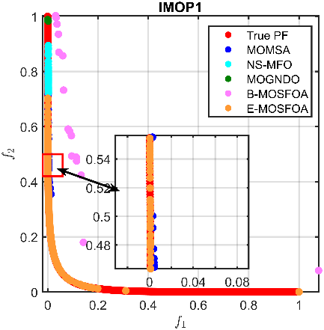 | 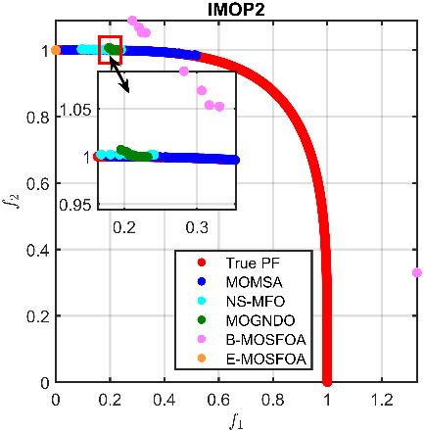 | 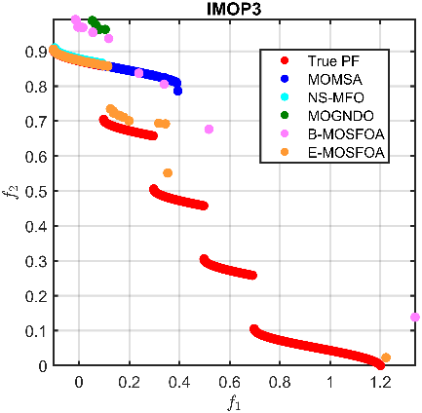
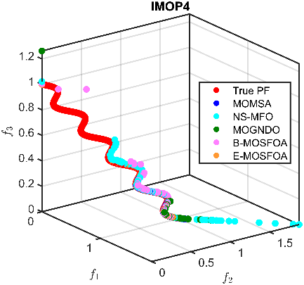 | 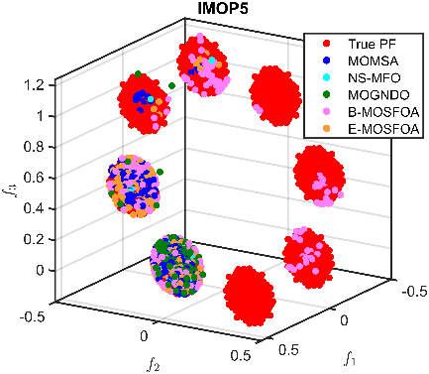 | 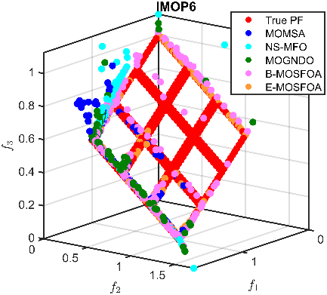
- Approximated Pareto fronts for IMOP problems. | 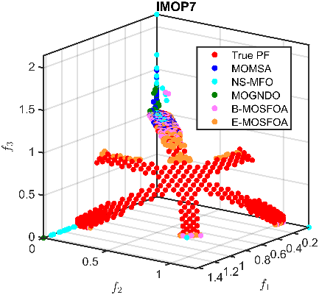 | 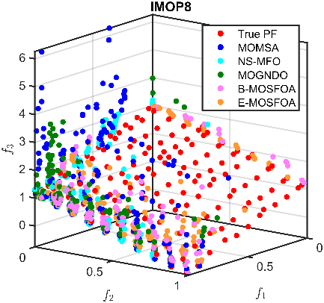
The suite-level results separate the roles of the two MOSFOA variants. B-MOSFOA is strongest on IMOP, where it has the best average rank (2.28) and 21 top-2 cases out of 32 problem-indicator combinations. E-MOSFOA has more rank-1 cases on IMOP and lower average ranks than B-MOSFOA on UF and RM-MEDA. The added adaptive operators, therefore, do not improve every problem family in the same way; their benefits are more evident across the broader UF and RM-MEDA suites. Figs. 2-7 provide the visual front and $IGD$ evidence, while Appendix Table A2-Table A4 give the underlying problem-level statistics.
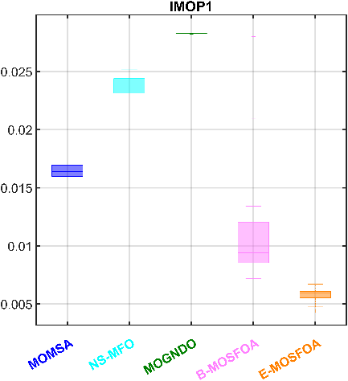 | 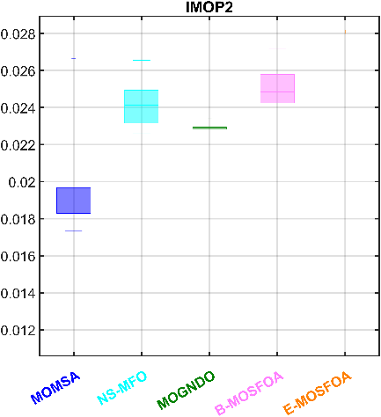 | 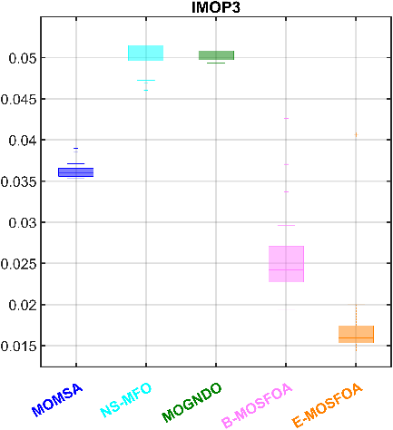
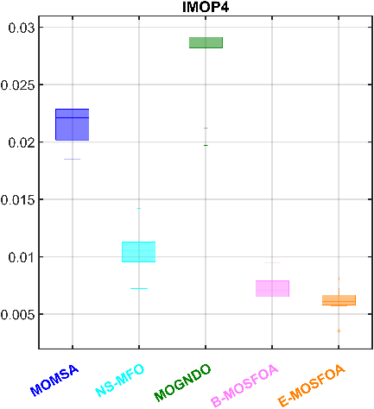 | 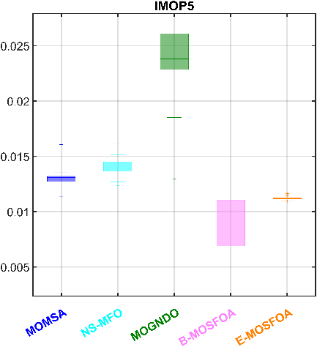 | 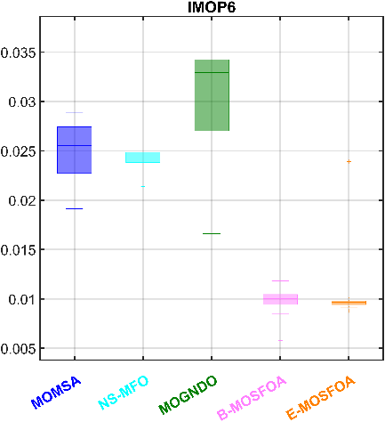
- $IGD$ comparison on IMOPs | 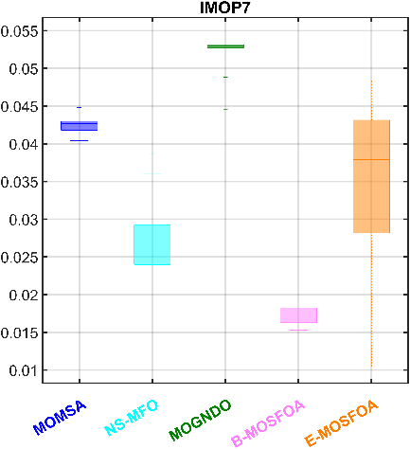 | 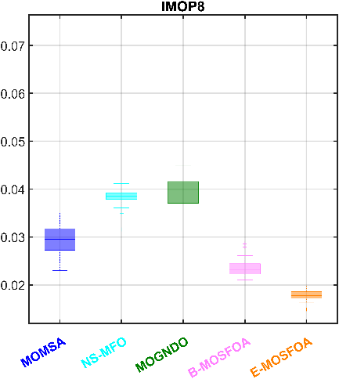
Figs. 2 and 3 summarize the $PF$ approximations and $IGD$ distributions for the IMOP suite, while Appendix Table A2 provides detailed indicator-level statistics. Across the 32 IMOP problem-indicator combinations, B-MOSFOA obtains the lowest suite-level average rank, while E-MOSFOA records more individual rank-1 cases. E-MOSFOA ranks first for both IGD and Ε on several IMOP problems, whereas B-MOSFOA ranks first for both indicators on selected cases such as IMOP5 and IMOP7.
The diversity indicators further distinguish between the two variants. B-MOSFOA performs well on $MS$ in selected cases, whereas E-MOSFOA gives strong $Δ$ results and additional competitive $MS$ values. The IMOP results favor B-MOSFOA in average rank but still retain E-MOSFOA as an important source of individual best cases.
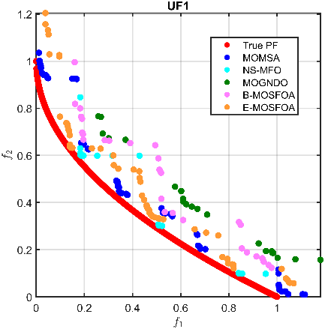 | 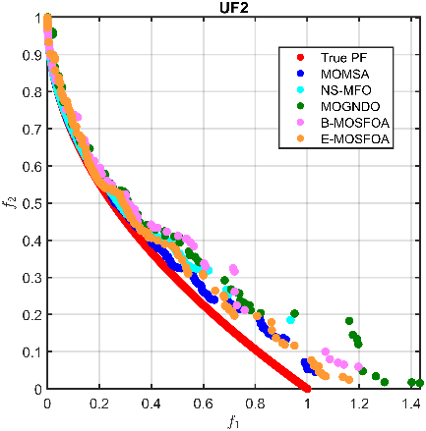 | 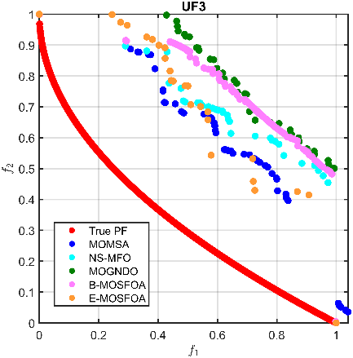
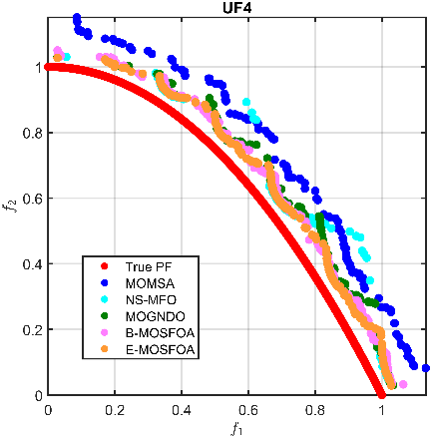 | 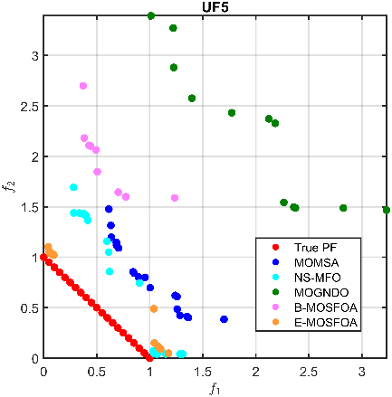 | 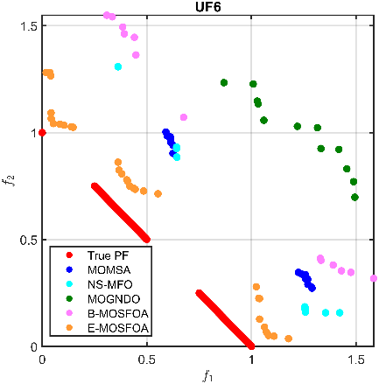
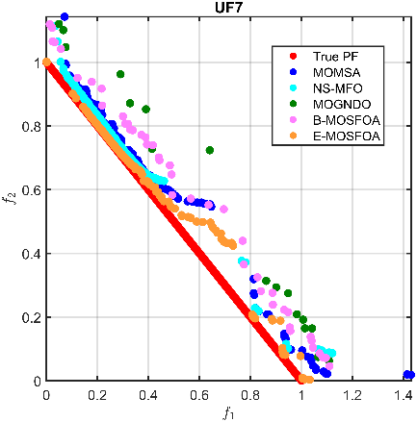 | 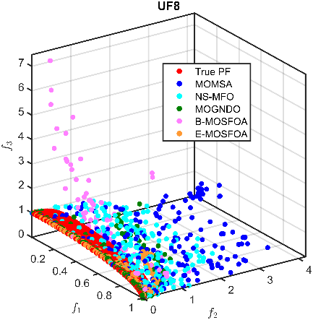 | 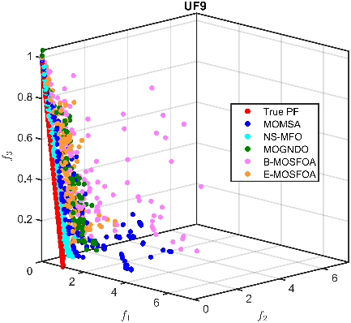
        - Approximated Pareto fronts for UF problems.
The UF suite gives a different ordering. Figs. 4 and 5 show more varied front shapes and $IGD$ distributions, and Appendix Table A3 reports the full indicator-level values. MOMSA has the best UF average rank, but E-MOSFOA is the better MOSFOA variant on this suite. Its first-rank results for $IGD$ and $ε$ on several problems are consistent with improved convergence accuracy.
B-MOSFOA remains relevant in the diversity indicators, with rank-1 $Δ$ and $MS$ results on several UF problems. The UF suite, therefore, shows a problem-dependent advantage of the enhanced search. E-MOSFOA improves the overall result, while the base archive mechanism still provides useful coverage for specific problems.
The RM-MEDA suite reinforces the problem-family dependence of the ranking. Figs. 6 and 7 show the corresponding $PF$ and $IGD$ patterns, and Appendix Table A4 gives detailed statistics. MOMSA again has the best suite-level average rank. E-MOSFOA ranks second, ahead of B-MOSFOA, NS-MFO, and MOGNDO, and it records more rank-1 and top-2 cases than B-MOSFOA.
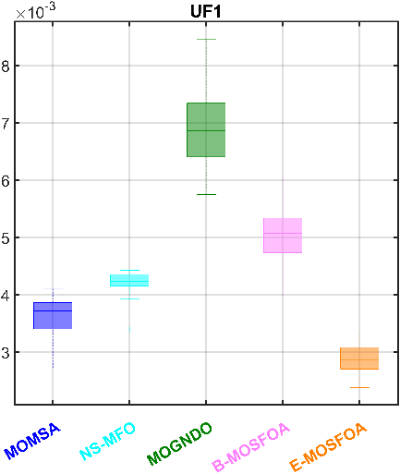 | 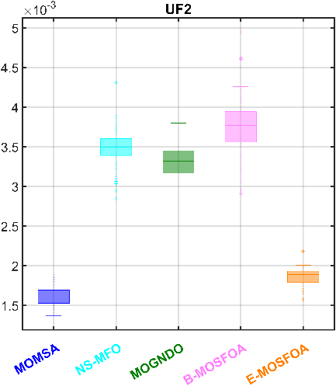 | 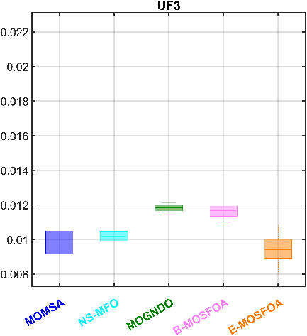
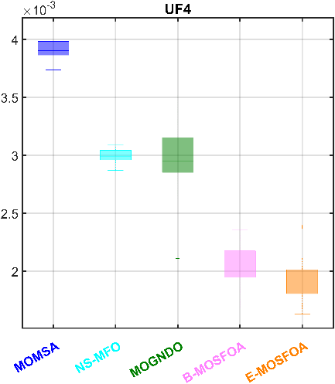 | 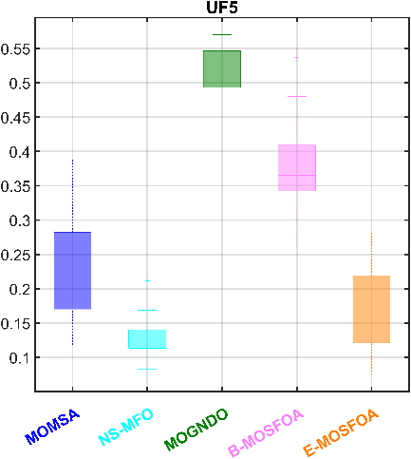 | 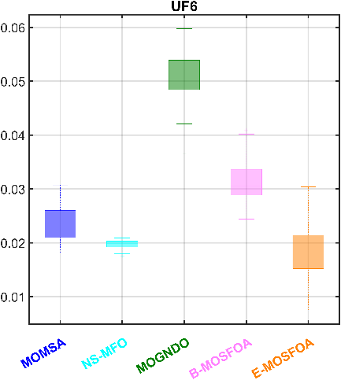
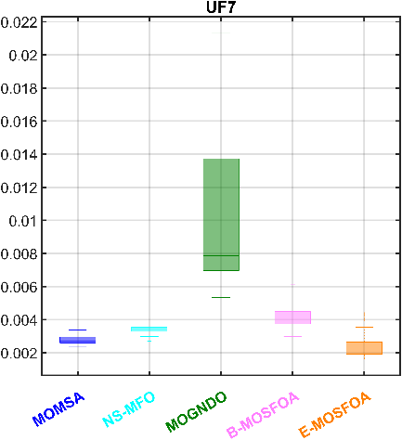 | 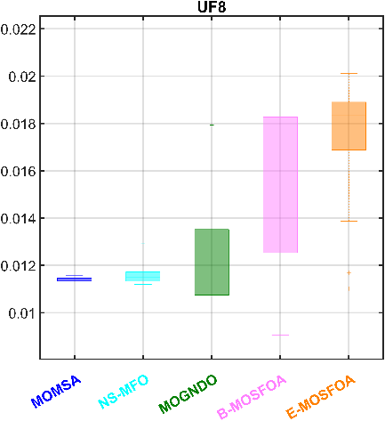 | 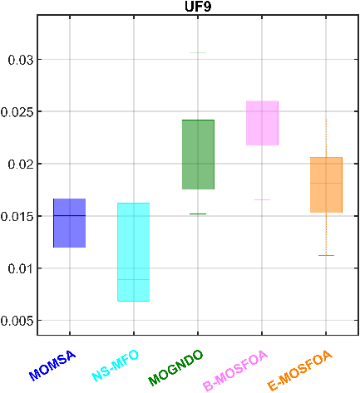
        - $IGD$ comparison on UFs
The Holm-adjusted tests support a cautious reading of this difference. Several RM-MEDA comparisons favor E-MOSFOA over B-MOSFOA, whereas other cases remain statistically indistinguishable. B-MOSFOA still gives better convergence values in selected problems, but E-MOSFOA has the lower aggregate RM-MEDA rank.
The benchmark results do not identify one dominant method for all suites and indicators. MOMSA has the best overall average rank, E-MOSFOA matches the highest number of rank-1 cases and has favorable Holm-adjusted counts against each comparator, and B-MOSFOA has the lowest runtime and the best IMOP average rank. Under this protocol, B-MOSFOA is the more economical archive-based variant. In contrast, E-MOSFOA incurs a small increase in runtime to obtain stronger aggregate statistical support across broader benchmark suites.
    - Parameter Sensitivity Analysis
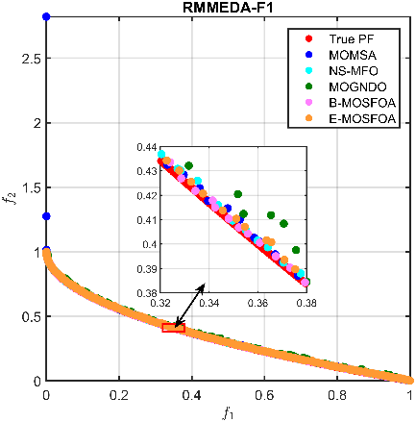 | 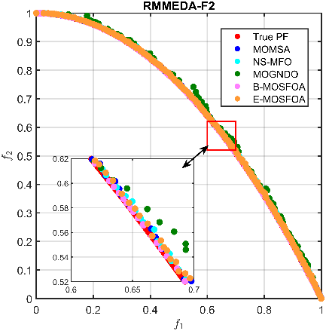 | 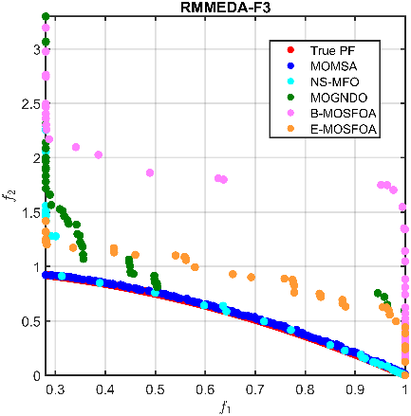
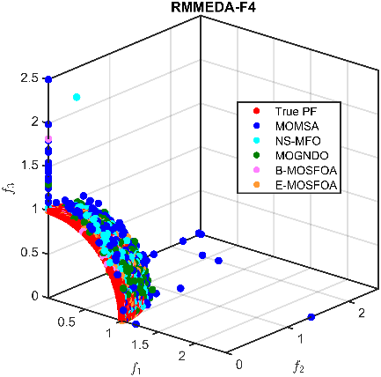 | 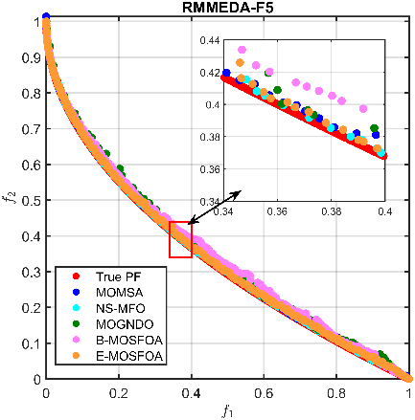 | 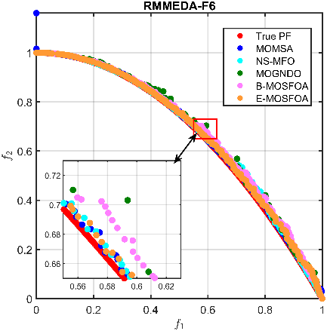
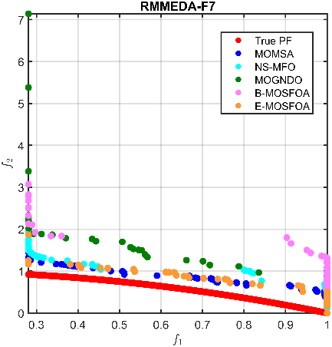 | 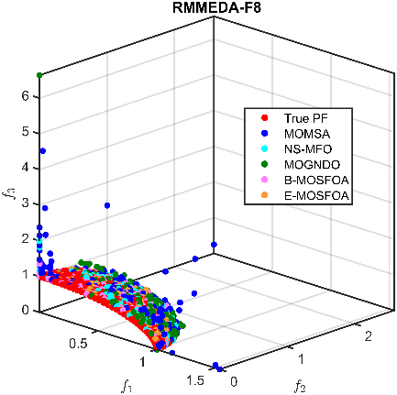 | 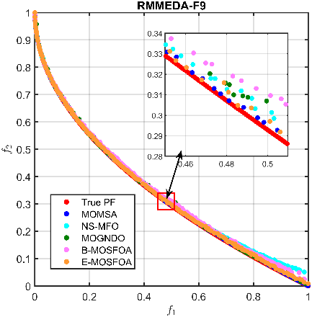
        - Approximated Pareto fronts for RM-MEDA problems.
A one-factor-at-a-time sensitivity analysis is carried out around the baseline setting $GP_{0}$=0.5, $N_{r}$=200, and $n_{grid}$=10. The three parameters affect different parts of the search. $GP_{0}$ controls the initial balance between exploration and exploitation, $N_{r}$ limits the external archive capacity, and $n_{grid}$ defines the density partition used for archive-based leader selection. The sensitivity set uses six representative benchmark problems, 30 independent runs per configuration, and the same evaluation budget as the main benchmark study. For each parameter setting, the reduced rank is computed from 24 outcomes, formed by six problems and four indicators. Table 5 reports this reduced summary together with Wilcoxon-Holm comparisons against the baseline and the mean runtime per run. Appendix Table A1 gives the corresponding indicator-level values for each benchmark-parameter setting, with B-MOSFOA and E-MOSFOA presented side by side.
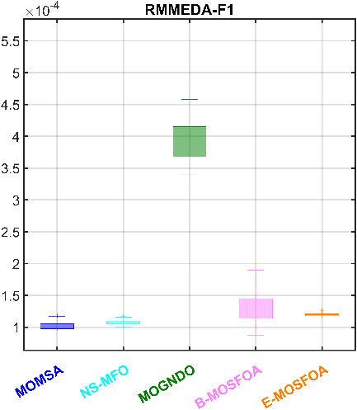 | 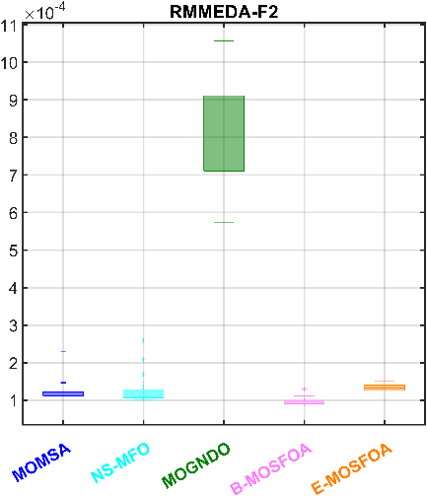 | 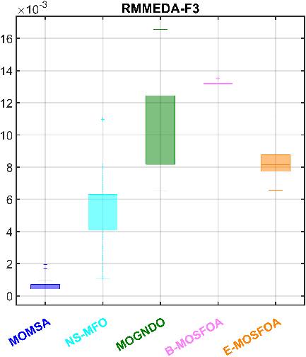
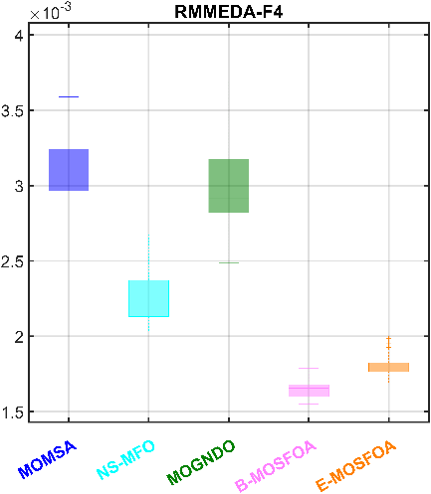 | 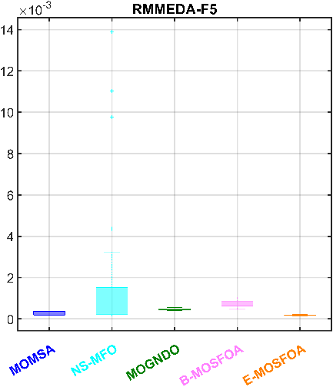 | 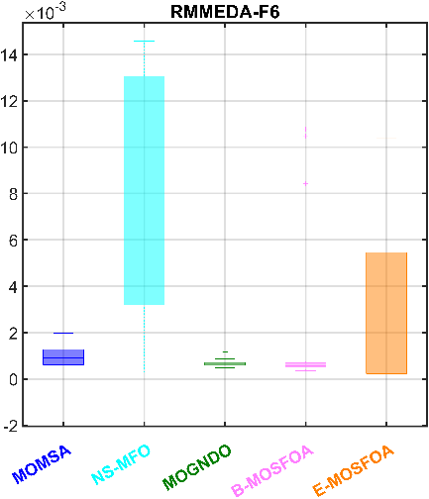
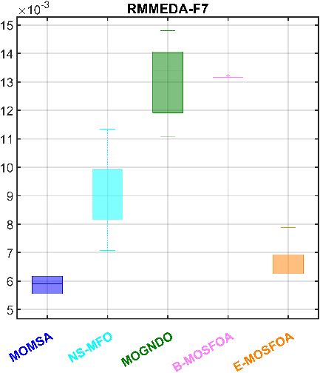 | 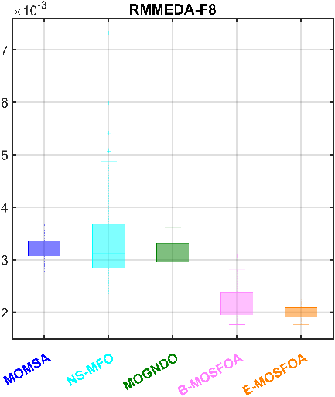 | 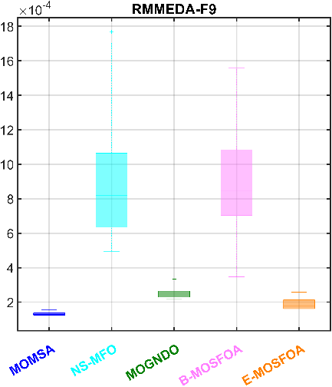
        - $IGD$ comparison on RM-MEDAs.
Table 5 shows that the parameter response is moderate and differs between the two MOSFOA variants. For B-MOSFOA, GP0=0.3 gives the lowest mean rank (3.25) and six rank-1 cases, but this setting is statistically indistinguishable from the baseline in all 24 Wilcoxon-Holm comparisons. Increasing $GP_{0}$ to 0.7 weakens the reduced rank. For E-MOSFOA, $GP_{0}$=0.7 gives the best reduced rank, whereas $GP_{0}$=0.3 performs poorest. Thus, the preferred exploration level is lower for B-MOSFOA and higher for E-MOSFOA.
Archive size mainly affects computational cost. $N_{r}$=100 gives the shortest runtime for both variants, while $N_{r}$=300 is the most expensive setting and does not provide a consistent rank advantage. The Wilcoxon-Holm subtotals further show that 121 of 144 B-MOSFOA comparisons and 111 of 144 E-MOSFOA comparisons remain statistically indistinguishable from the baseline. The baseline setting is therefore retained for the main benchmark comparison as a stable, non-extreme choice, while the sensitivity results suggest $GP_{0}$ as the most useful parameter for optional further tuning.
- Reduced parameter-sensitivity ranking for B-MOSFOA and E-MOSFOA.
Algorithm | $$GP_{0}$$ | $$N_{r}$$ | $$n_{grid}$$ | Mean rank | Best-count/24 | Wilcoxon-Holm  vs baseline (+/=/-) | Mean runtime/run (s)
B-MOSFOA | 0.5 | 200 | 10 | 3.38 | 3 | Baseline | 27.90
 | 0.3 | 200 | 10 | 3.25 | 6 | 0/24/0 | 29.25
 | 0.7 | 200 | 10 | 4.71 | 2 | 1/17/6 | 23.64
 | 0.5 | 100 | 10 | 3.96 | 4 | 1/19/4 | 16.32
 | 0.5 | 300 | 10 | 4.00 | 2 | 2/19/3 | 38.75
 | 0.5 | 200 | 15 | 3.88 | 2 | 0/24/0 | 27.25
 | 0.5 | 200 | 5 | 4.83 | 3 | 2/18/4 | 25.89
 | Wilcoxon-Holm no-difference subtotal |  |  |  |  | 121/144 | -
E-MOSFOA | 0.5 | 200 | 10 | 4.33 | 0 | Baseline | 33.52
 | 0.7 | 200 | 10 | 3.50 | 5 | 4/18/2 | 33.21
 | 0.3 | 200 | 10 | 5.13 | 0 | 3/13/8 | 32.39
 | 0.5 | 300 | 10 | 3.71 | 5 | 4/19/1 | 50.84
 | 0.5 | 100 | 10 | 4.13 | 4 | 2/17/5 | 20.47
 | 0.5 | 200 | 5 | 3.58 | 6 | 2/22/0 | 32.33
 | 0.5 | 200 | 15 | 3.63 | 2 | 1/22/1 | 34.17
 | Wilcoxon-Holm no-difference subtotal |  |  |  |  | 111/144 | -
  - Case Study: Liquid Bulk Jetty
    - Project Baseline and Structural Models
The engineering application considers three interacting subsystems of the Hai Linh liquid-bulk jetty: the berthing dolphin (BD), a mooring dolphin (MD), and a main jetty platform (MJP). Their pile arrangements, finite-element model idealizations, and cross-sections are assembled in Fig. 8, while Tables 6 and 7 define the load combinations and design variables. This application is demanding because discrete pile sections, continuous geometric variables, soil-dependent pile resistance, and nonlinear cost-stiffness trade-offs must be evaluated through repeated SAP2000 analyses.
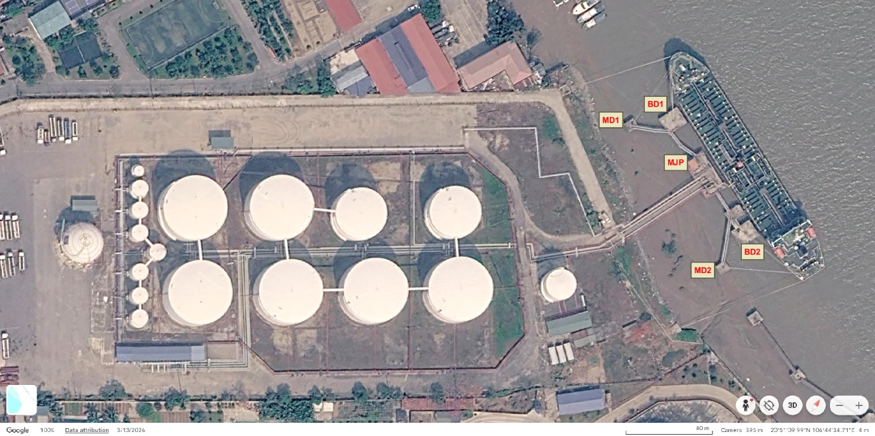
a) Google Earth imagery of the study site © 2026 Google; imagery date 13 March 2026; accessed 11 July 2026; the native Google and data-attribution strip is retained within the image.
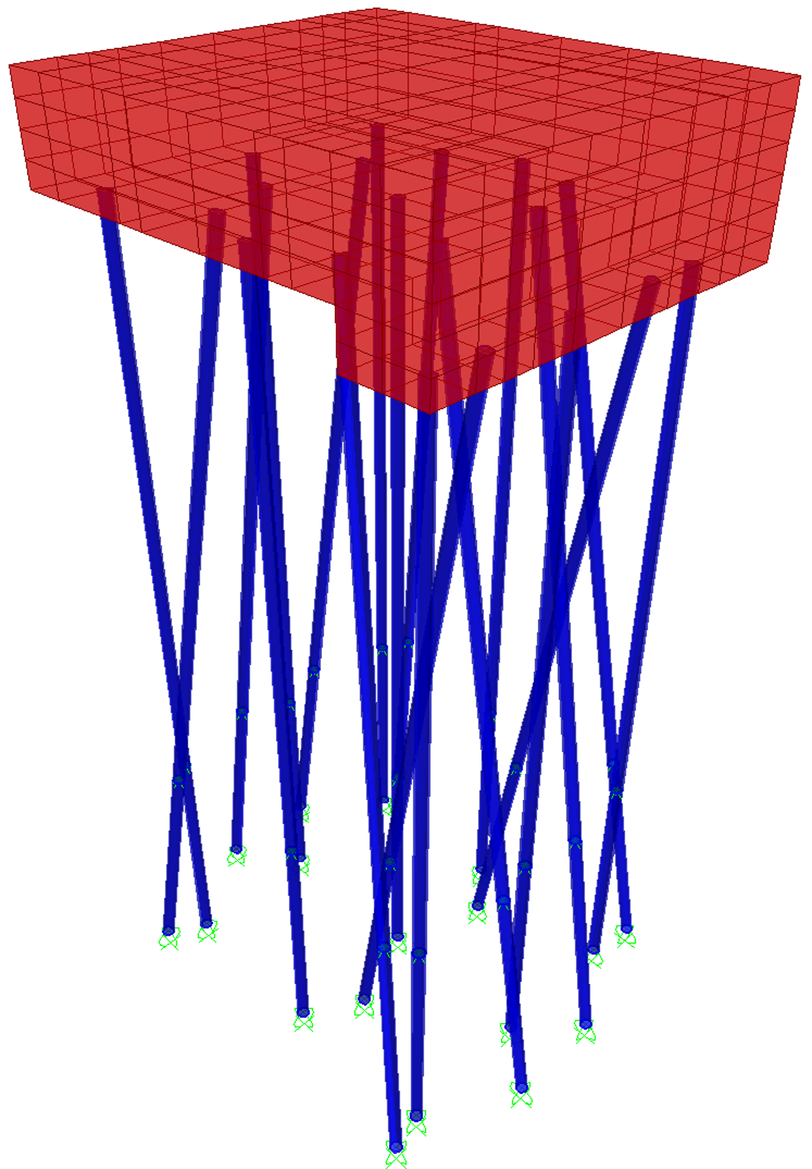 | 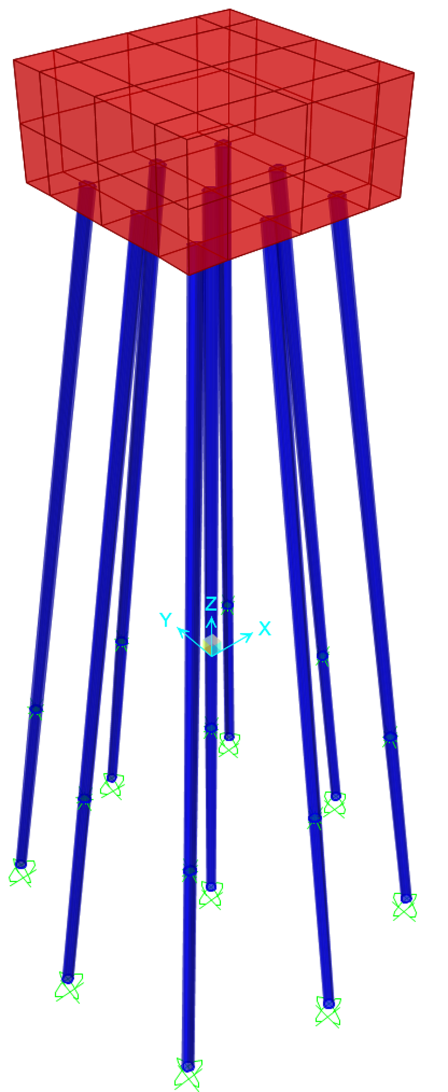 | 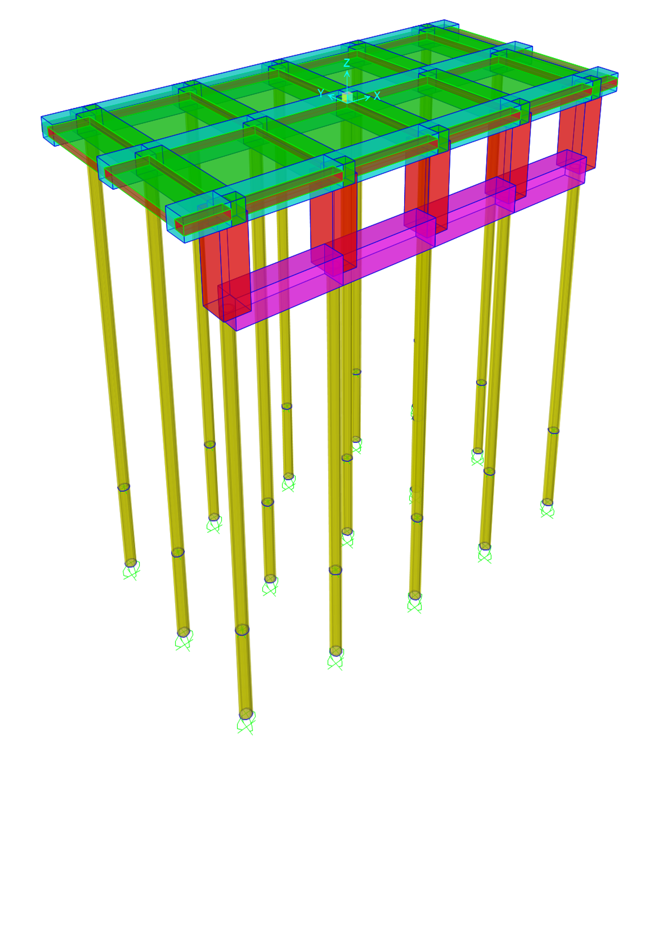
b) FEM model of BD; | c) FEM model of MD; | d) FEM model of MJP;
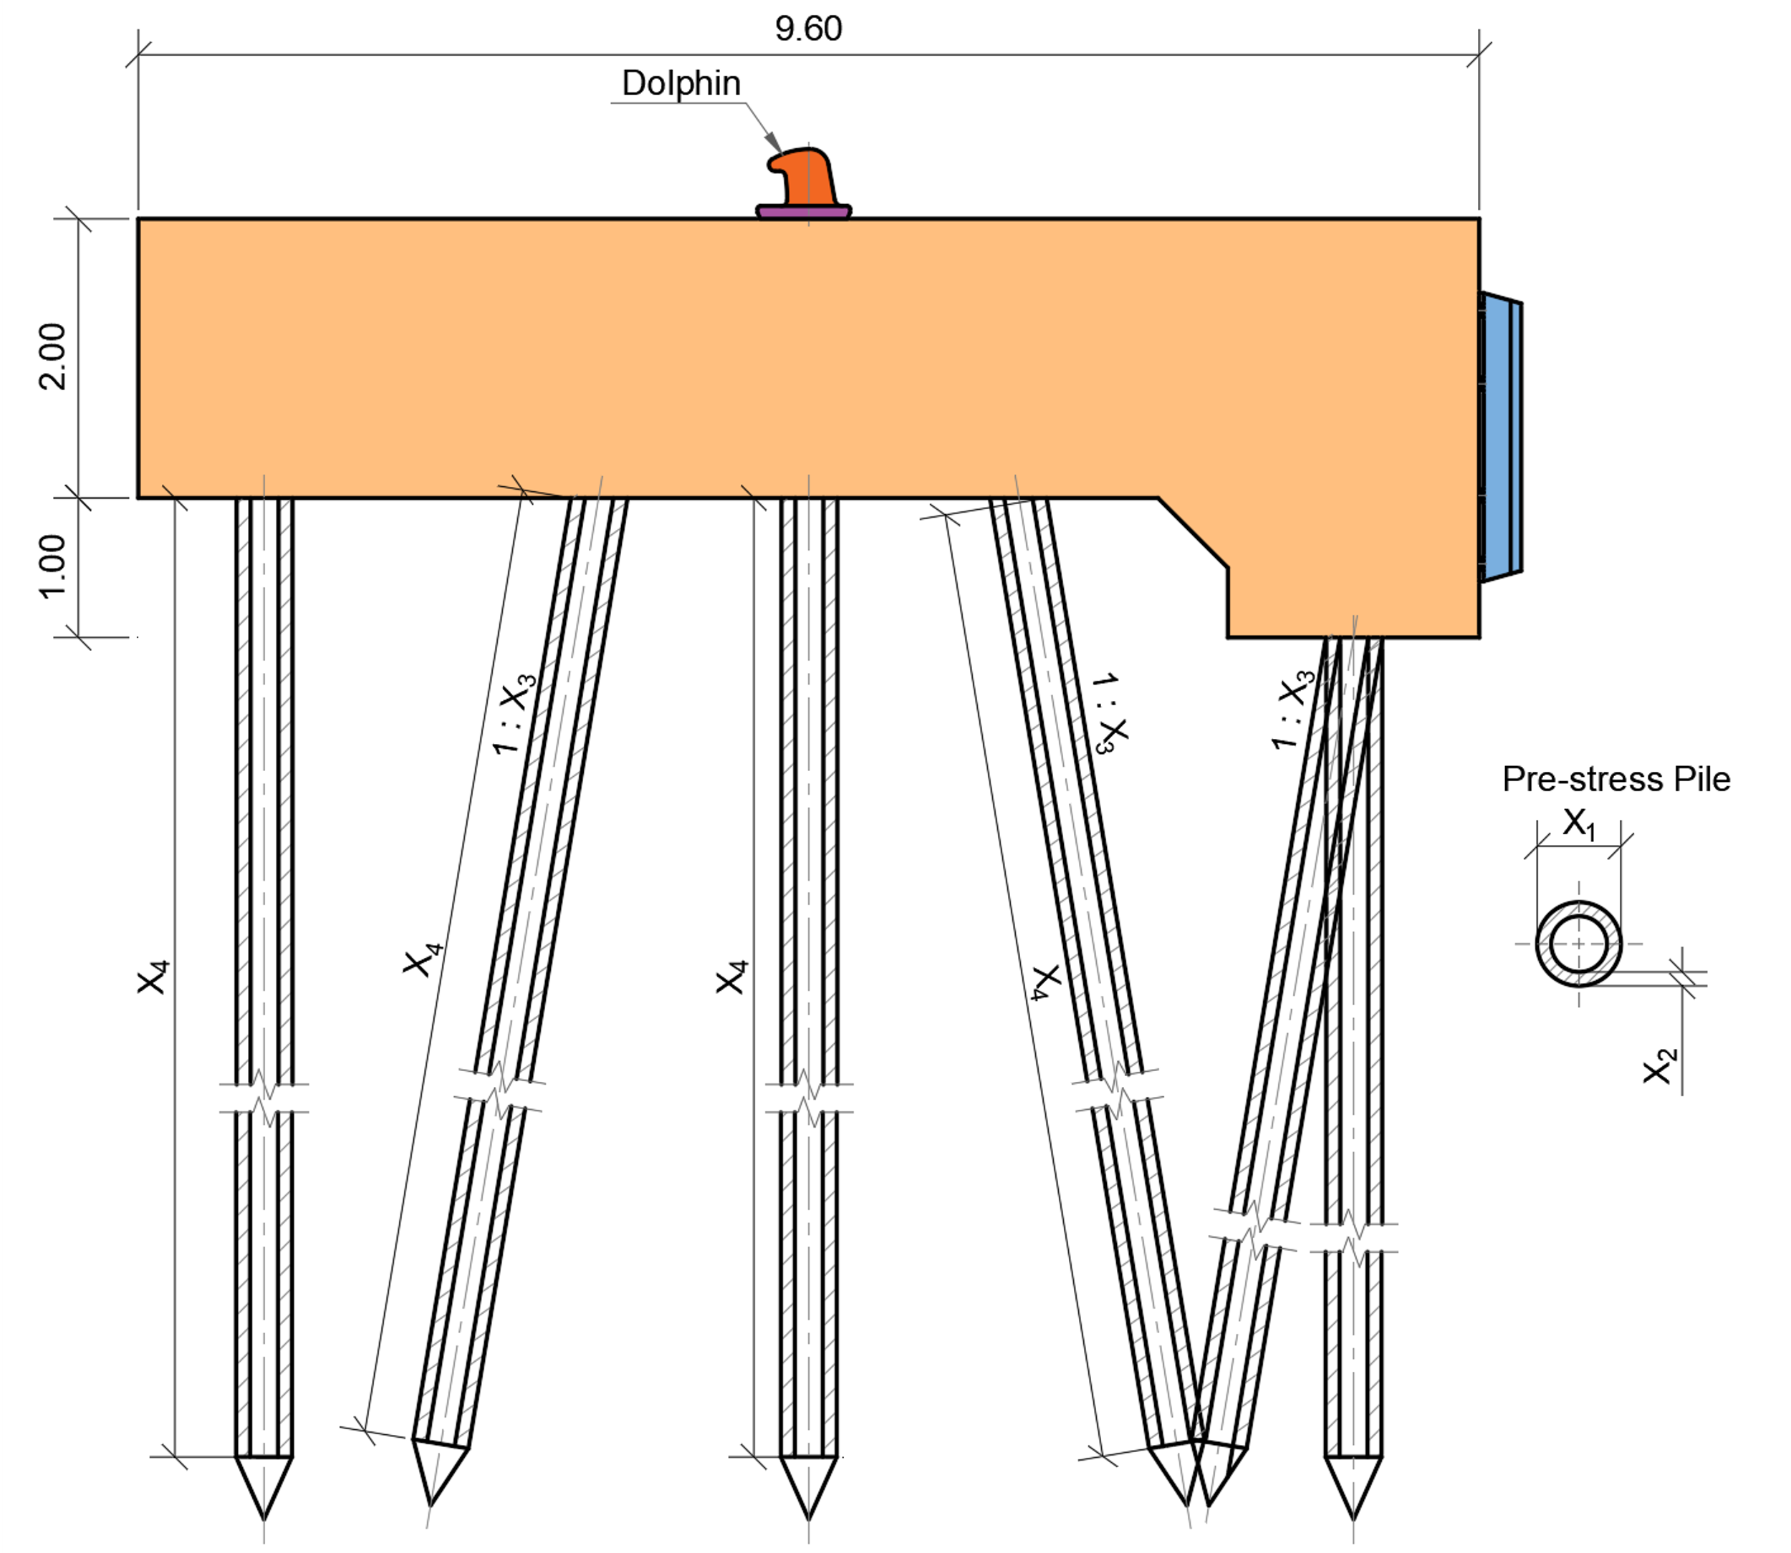 | 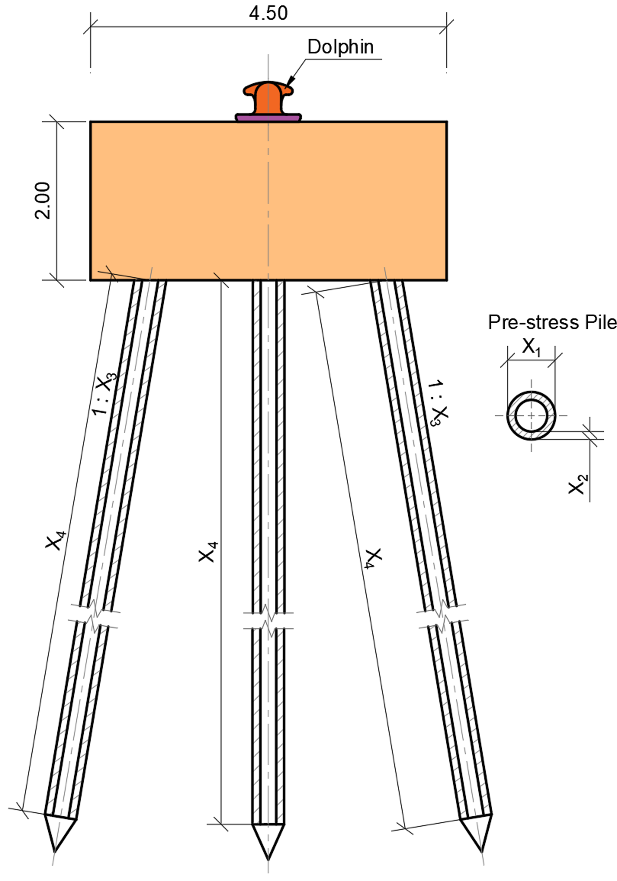 | 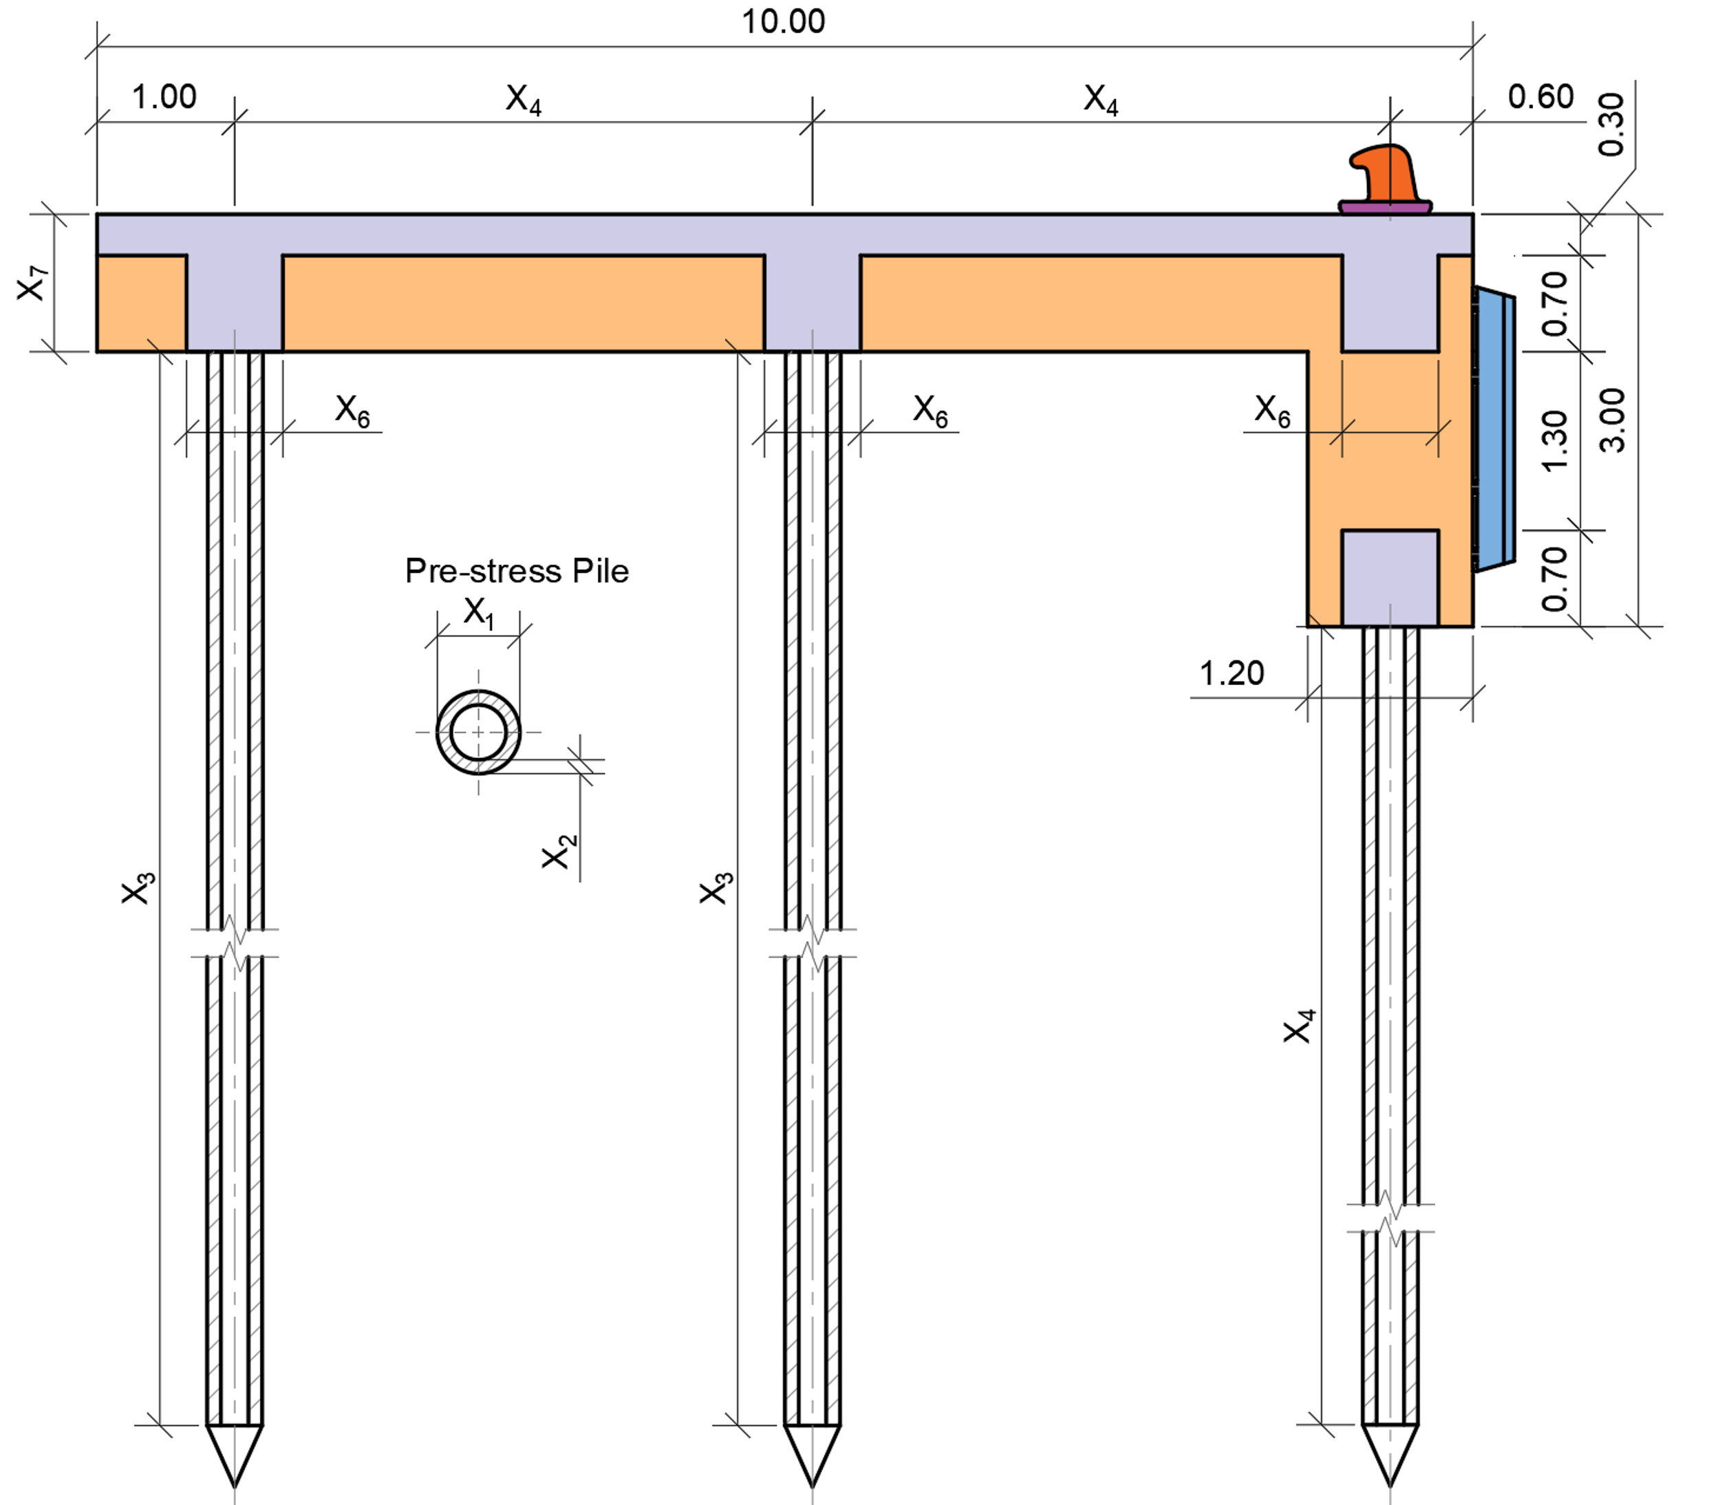
e) BD cross-section; | f) MD cross-section; | g) MJP cross-section;
        - Location and structural idealization of the Hai Linh liquid-bulk jetty.
BDs absorb and redistribute the kinetic energy and horizontal forces generated during ship berthing and also provide support for mooring operations. The current BD comprises 19 D600 prestressed-concrete piles with a nominal length of 39m: nine vertical piles, six in-plane raker piles at a slope of 1:6, and four spatial raker piles at the same slope with plan orientations of 30° or 60°. This arrangement develops resistance in both the principal and diagonal loading directions, as shown in Fig. 8(b) and (e).
MDs anchor the mooring lines and resist the lateral and tensile actions generated by vessel motion under wind, waves, and tides. The current MD comprises nine D600 prestressed-concrete piles: one vertical pile, four in-plane raker piles at a 1:6 slope, and four spatial raker piles at the same slope with a plan orientation of 45°. The combination of vertical and raker piles provides multidirectional resistance to the mooring actions, as shown in Fig. 8(f).
Both BD and MD pile systems support cast-in-place C40/50 reinforced-concrete caps. The BD cap measures 8.4×9.6 m and varies in depth from 2.0 to 3.0 m; its locally deepened fender-mounting region increases flexural and shear resistance and provides a larger anchorage area. The 4.5×4.5×2.0 m MD cap connects the pile heads and transfers the mooring actions to the foundation. The SAP2000 models in Fig. 8 (b) and (c) represent the complete pile-and-cap geometries. For each candidate design, the applicable load combinations of the dead load (DL), the berthing load (BL), and the mooring load (ML) in Table 6 are analyzed, and the maximum displacement and governing pile forces and bending moments are returned to MATLAB for objective and constraint evaluation.
The MJP is a reinforced concrete deck structure connecting the BDs and MDs, serving as the main operational platform for petroleum transport and supporting equipment. Vertical prestressed concrete piles support the MJP, which includes transverse beams, longitudinal beams, and a cast-in-place reinforced concrete deck. Unlike BD and MD, the MJP does not receive direct ship impact loads; its design considers dead load and live load (LL) from equipment and personnel.
- Load cases and combinations for jetty subsystems
Structures | Load cases | Combinations (Linear Add)
 |  | COMB1 | COMB2 | COMB3
BD | DL | 1.0 | 1.0 | 1.0
 | BL | --- | 1.0 | ---
 | ML | --- | --- | 1.0
 | Envelop combination (EV-COMB) | Yes | Yes | Yes
MD | DL | 1.0 | 1.0 | ---
 | ML | --- | 1.0 | ---
 | EV-COMB | Yes | Yes | ---
MJP | DL | 1.0 | 1.0 | ---
 | LL | --- | 1.0 | ---
 | EV-COMB | Yes | Yes | ---
The engineering baselines are established from non-public project records made available to the authors for research verification. The 2020 as-built drawing dossier records the completed BD and MD configurations [39], whereas the 2023 periodic-inspection calculation dossier describes all three subsystems, including their geometry, soil conditions, design actions, and structural arrangements [40]. On this basis, the numerical baselines are rebuilt within the same MATLAB-SAP2000 workflow applied throughout the study. For BD and MD, the pile rake is 1:6, represented by $n_{θ}=6$, and the nominal pile length is 39 m; the MJP baseline uses vertical D500 piles with a nominal length of 38 m. Reanalysis under a common model ensures that differences arise from the design variables rather than from inconsistent modeling or loading assumptions.
Table 6 reports the linear-combination coefficients and identifies the combinations included in the SAP2000 envelope combination, whereas Table 8 gives the numerical load components entered into the analysis model. The unit values in Table 6 are therefore combination scale factors, not load magnitudes or safety factors. Action-specific coefficients are applied when the berthing, mooring, and operational loads are established, while reliability, overload, working condition, and resistance factors are applied in the corresponding capacity checks. EV-COMB is an envelope combination rather than a linear combination: it evaluates each listed combination separately and retains the governing maximum and minimum responses for each subsystem.
    - Objective Functions
The engineering problem considers two objectives to be minimized: construction cost $\left(f_{1}\left(X\right)\right)$ and maximum structural displacement $\left(f_{2}\left(X\right)\right)$. Cost measures material and foundation demand, whereas maximum displacement represents the global stiffness and serviceability response of each subsystem. Treating displacement as an objective rather than assigning an arbitrary preference weight reveals the additional cost of achieving a stiffer design. Strength, geotechnical, and geometric requirements remain explicit constraints and are not traded against economy.
$$\underset{X}{minimize}{F\left(X\right)}=\left\{f_{1}\left(X\right),f_{2}\left(X\right)\right\},$$ | (14)
$$In which: f_{1}\left(X\right)=\left\{\begin{matrix}\sum_{i=1}^{N_{p}}{L_{p,i}P_{p}} & for MD, BD, \\ \sum_{i=1}^{N_{p}}{L_{p,i}P_{p}}+\sum{V_{beam,i}}P_{cr}+\sum{M_{s,i}}P_{st} & for MJP.\end{matrix}\right.$$ | (15)
Where $X$ is the design vector containing the variables listed in Table 7 for the corresponding subsystem. In Eq. (15), $N_{p}$ is the total number of piles; $L_{p,i}$ is the length of the pile; and $P_{p}$is the price of a pile per metre; $V_{beam,i}$ and $M_{s,i}$ are the concrete volume and reinforcement mass of beam $i$; and $P_{cr}$ and $P_{st}$ are the unit prices of concrete and reinforcement.
Eq. (15) defines $f_{1}$ by subsystem: the first branch gives the pile cost for BD and MD, whereas the second adds beam-concrete and reinforcement costs for MJP. For MJP, SAP2000 designs the reinforced-concrete beams according to CSA A23.3-14 [41]; the resulting concrete volume and reinforcement mass supply the quantities used in the second branch of Eq. (15), while the associated strength requirements are defined in Section 4.4.
- Design variables for BD, MD, and MJP structures.
Structures | Variable | Description | Type | Range & References
BD, MD | $X_{1}$ | $D_{p}$ - Pile outside diameter (m) | Discrete | Ref. [3]
 | $X_{2}$ | $t_{p}$ - Pile wall thickness (m) | Discrete | Ref. [3]
 | $X_{3}$ | $n_{θ}$ - Pile rake parameter in the ratio 1:$n_{θ}$ | Discrete | [6,7,8]
 | $X_{4}$ | $L_{p}$ - Pile length (m) | Discrete | [1:0.1:40]
MJP | $X_{1}$ | $D_{p}$ - Pile outside diameter (m) | Discrete | Ref. [3]
 | $X_{2}$ | $t_{p}$ - Pile wall thickness (m) | Discrete | Ref. [3]
 | $X_{3}$ | $L_{p}$ - Pile length (m) | Discrete | [1-40]
 | $X_{4}$ | $l_{1}$ - Longitudinal beam span (m) | Discrete | [3-6]
 | $X_{5}$ | $l_{2}$ - Transverse beam span (m) | Discrete | [3-6]
 | $X_{6}$ | $b$ - Beam width (m) | Discrete | [0.5-2]
 | $X_{7}$ | $h$ - Beam height (m) | Discrete | [0.5-2]
An indicative 2025 price basis is adopted to compare optimization outcomes rather than prepare a tender estimate. Official Hai Phong announcements provide the primary references for prestressed concrete piles, concrete, and reinforcement [42, 43], while public supplier lists supplement unlisted pile diameters and classes. This same traceable dataset is fixed for every candidate in this research and does not replace project-specific quotations. VND equivalents use the calculation rate of 1 USD = 24,500 VND. BD and MD costs depend on pile length and unit price; MJP additionally includes beam concrete and reinforcement, with $P_{cr}$=46.25 USD/m3 and $P_{st}$=0.57 USD/kg. These inputs and the class-specific pile-price ranges are consistent in order of magnitude with the official 2025 Hai Phong prices.
    - Design Loads and Geotechnical Modeling
The engineering model follows the standards used to define the current design and its reanalysis: TCVN 7888:2014 for prestressed piles [3], TCVN 10304:2014 for pile foundations [4], PIANC and OCDI for berthing actions [1, 2], and 22 TCN 222-95 for vessel-induced mooring actions [44]. The berthing calculation includes the hydrodynamic mass, eccentricity, berth configuration, and fender-softness coefficients; the selected fender reaction is increased by 10% in accordance with the manufacturer's recommendation recorded in the project calculation dossier [40].
- Load cases and corresponding load values.
Load case | Type | Design type | Values |  |  | References
 |  |  | $X$ | $Y$ | $Z$
DL | Static | Dead | --- | --- | --- | Computed internally by SAP2000
BL | Static | Live | 222.42(kN) | 444.83(kN) | 0 | [1, 2]
ML | Static | Live | 99.05(kN) | 118.07(kN) | 71.2 | [1, 2]
LL | Static | Live | 0 | 0 | 9.81(kN/m²) | [1, 2]
Table 8 reports the actual inputs to the SAP2000 models. The dead load is generated from the self-weight multiplier. The berthing load components are 222.42, 444.83, and 0 kN in the global $X$, $Y$, and $Z$ directions; the mooring load components are 99.05, 118.07, and 71.20 kN. The live load of MJP is a vertically distributed intensity of 9.81 kN/m². These values remain fixed for every candidate.
The soil profile consists mainly of cohesive strata with deeper sandy deposits; Table 9 lists the parameters used in two separate soil-related calculations. Axial compression and uplift capacities are evaluated over the full embedded pile length in accordance with TCVN 10304:2014 [4], and the SAP2000 pile reactions are checked against these capacities. Lateral soil restraint is represented through an equivalent-support idealization based on the calculated flexural depth. For the layered profile, the equivalent subgrade coefficient $k_{eq}$ gives $α_{e}={\left[\frac{b_{p}k_{eq}}{γ_{c}E_{0}I}\right]}^{\frac{1}{5}}$ and the active flexural depth is $l_{u}=\frac{2}{α_{e}}$, where $b_{p}$ is the equivalent pile width, $E_{0}I$ is pile flexural rigidity, and $γ_{c}$ is the working-condition coefficient. In SAP2000, soil effects are replaced by a guided support located within the soil at $l_{u}$, together with a roller support at the pile toe. The physical pile length is retained in the capacity and pile-tip checks, see Fig. 8 (b), (c) and (d).
- Soil properties
Layer No. | Soil Type | State | Thickness (m) | Liquidity index parameter ($I_{L}$)
1. | Clay | Soft to very soft | 4.8 | 0.76
2. | Clay | Stiff to hard | 5.3 | 0.31
3. | Clay | Soft | 9.6 | 0.63
4. | Clay | Stiff to hard | 1.7 | 0.35
5. | Clay | Soft | 4.9 | 0.67
6. | Sand | Medium-grained | 2.3 | 0.20
    - Constraint Handling and Feasibility Verification
Feasibility is assessed at three levels. First, geotechnical and geometric admissibility conditions are checked before FEM analysis. SAP2000 then provides the member actions and support reactions required for the resistance checks. Finally, the stored diagnostics of every final-archive member are audited after optimization. This sequence distinguishes a candidate that fails the model-admissibility conditions from an analyzable design that violates one or more resistance limits.
The pre-analysis conditions require $L_{p}≥l_{u}$, $I_{L,tip}<0.40$, and $h_{bearing}≥2.0$m. For MJP, the additional compatibility condition is $B_{beam}≥D_{p}+0.20$m. These checks ensure that the physical pile is not shorter than its calculated flexural length, that the pile tip lies within the adopted competent-soil range, that the layer containing the tip has adequate thickness, and that the supporting beam can accommodate the pile. Failure of any condition assigns ${10}^{9}$ to both objectives; a completed SAP2000 analysis is required before the remaining checks are evaluated.
For MJP, the SAP2000 concrete design routine designs reinforced-concrete beams according to CSA A23.3-14 [41]. The required reinforcement returned by SAP2000 is used in the construction-cost calculation. Because the code-based beam-design results are not formulated as explicit MATLAB penalty residuals, the equations below are restricted to the pile constraints implemented directly in the optimization routine.
For all three subsystems, the pile checks are written as non-negative residuals, so a value of zero denotes satisfaction and a positive value measures exceedance.
$$g_{ax}\left(X\right)=\sum_{j=1}^{n_{p}}{\max\left(\left|R_{z,j}^{FEA}\right|-N_{c,d}, 0\right)},$$ | (16)
$$g_{M,k}\left(X\right)=\max\left(\left|M_{k}^{FEA}\right|-M_{c,r}, 0\right), k∈\left\{2,3\right\},$$ | (17)
$$g_{up}\left(X\right)=\max\left(U_{d}-U_{r}, 0\right),$$ | (18)
$$U_{r}=R_{DL}^{FEA}+n_{p}N_{u,d},$$ | (19)
$$N_{u,d}=\frac{γ_{0}γ_{ck}}{γ_{n}γ_{k}} u\sum_{i}{γ_{cf}}f_{i}l_{i}$$ | (20)
$$N_{c,d}=\frac{γ_{0}γ_{c}}{γ_{n}γ_{k}}\left(γ_{cq}q_{b}A_{b}+u\sum_{i}{γ_{cf}}f_{i}l_{i}\right).$$ | (21)
Eqs. (16)-(20) define the pile-constraint residuals and the terms used to determine uplift resistance. Eq. (16) sums over all $n_{p}$ piles, the amount by which the absolute axial reaction $\left|R_{z,j}^{FEA}\right|$ exceeds the design compressive resistance $N_{c,d}$ and FEA denotes finite-element analysis. Eq. (17) compares the maximum pile moment $\left|M_{k}^{FEA}\right|$ about each local axis $k=2, 3$ with the pile bending resistance $M_{c,r}$. Eq. (18) compares the uplift demand $U_{d}$ with the total uplift resistance $U_{r}$. Each constraint residual is zero when the corresponding demand does not exceed its resistance and otherwise equals the positive exceedance. The uplift constraint applies to BD and MD and is taken as zero for MJP.
In Eq. (19), $R_{DL}^{FEA}$ is the stabilizing dead-load reaction obtained from SAP2000, and $N_{u,d}$ is the design shaft-uplift resistance of one pile; hence, $U_{r}$ includes the dead-load contribution and the shaft resistance of all piles. Eqs. (20) and (21) evaluate the shaft-uplift and compressive resistances, respectively, according to TCVN 10304:2014 [4]. The adopted values are $γ_{0}=1.15$ for the foundation working condition, $γ_{n}=1.15$ for structural importance, and $γ_{k}=1.55$ for pile-capacity reliability. The pile working-conditioning factor is $γ_{c}=1.00$ in compression and $γ_{ck}=0.80$ in uplift; the soil working-conditioning factors are $γ_{cq}=1.00$ at the pile tip and $γ_{cf}=0.80$ along the shaft. Here, $q_{b}$ is unit pile-tip resistance, $A_{b}$ is pile-tip area, $u$ is pile perimeter, and $f_{i}$ and $l_{i}$ are unit shaft resistance and embedded pile length within soil layer $i$, respectively.
If one or more of the resistance conditions above are violated, the corresponding exceedances are combined into the penalty $P(X)$ and added to both objectives. The original objective vector $F(X)$ in Eq. (14) then becomes the following penalized vector $F^{p}(X)$
$$\underset{X}{minimize}{F^{p}\left(X\right)=\left[f_{1}\left(X\right)+P\left(X\right), f_{2}\left(X\right)+P\left(X\right)\right]},$$ | (22)
$$P\left(X\right)=α\left[g_{M,2}\left(X\right)+g_{M,3}\left(X\right)+g_{ax}\left(X\right)+g_{up}\left(X\right)\right], α={10}^{9}.$$ | (23)
Eqs. (22) and (23) apply the common coefficient $α={10}^{9}$ to exceedances of the pile-resistance limits to form a penalty, which is then added to both objectives. The uplift constraint applies to BD and MD and is set to zero for MJP. The penalty increases both objective values in proportion to the constraint exceedance, thereby helping to exclude violating candidates from the Pareto archive. If a hard pre-analysis condition is violated, the SAP2000 analysis is bypassed, and both objective values are set directly to ${10}^{9}$. A candidate is therefore regarded as feasible when $P(X)=0$ and all hard pre-analysis conditions are satisfied. After optimization, every final-archive member is matched to its stored diagnostic data to confirm a zero penalty, satisfaction of all hard conditions, and demand-to-resistance ratios not exceeding 1.0.
    - Optimization Results and Engineering Interpretation
In this section, the six MATLAB-SAP2000-coupled engineering optimization problems are performed using the same numerical protocol, comprising a population of 100, 300 iterations, a 100-solution external archive, a 10-division adaptive grid, and $GP_{0}=0.5$. This setting produces 30,100 objective-function evaluations for each algorithm-case pair. All runs are carried out on the same workstation (Intel Xeon E5-2667 v2, 16 physical cores, 32 logical processors, and 64 GB RAM), with 25 parallel SAP2000 instances activated for each problem. Within each subsystem, normalized $HV$ [45] is computed from the same cost-displacement ranges and the reference point (1.1, 1.1).
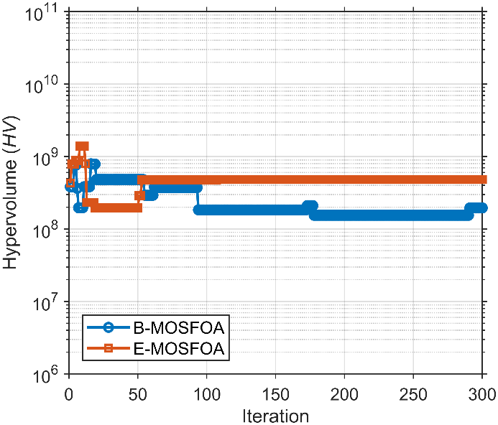 | 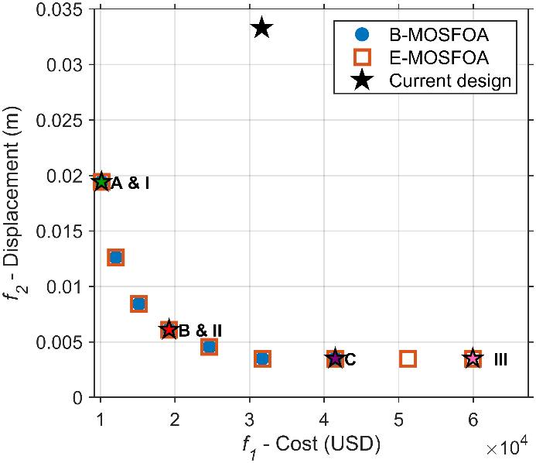
a) $HV$ convergence; | b) $PF$s obtained by B-MOSFOA and E-MOSFOA compared with the current design.
        - Optimization results for BD structure.
After each optimization, three representative designs are extracted from the final archive: the minimum-cost design, the minimum-displacement design, and the compromise design. The compromise design is the Pareto solution closest to the ideal point after cost and displacement are normalized to the same scale [6, 46]. Because each algorithm-case pair is represented by a single recorded engineering run, these designs are interpreted as feasible Pareto alternatives rather than statistical evidence of algorithmic superiority. Pile diameter and wall thickness are encoded jointly by a discrete pile-type variable; hence, MJP has six encoded variables although diameter and thickness are reported separately.
Fig. 9 and Table 10 summarize the recorded BD HV history and the final cost-displacement archive. The two algorithms identify the same minimum-cost design A/I and compromise design B/II. Relative to the current design, A/I reduces cost by 67.9% and displacement by 41.7%; B/II reduces them by 39.2% and 81.7%, respectively. The minimum-displacement designs C and III both reduce displacement by 89.5%, but C costs 30.8% less than III. Since A/I improves both objectives simultaneously, the current design is dominated within the investigated design space.
- Representative optimized BD designs and the current design.
Algorithm | Design | Pile type ($D_{p}$×$t_{p}$; $P_{p}$ (USD/m)) | $n_{θ}$ | $L_{p}$ (m) | $f_{1}$ (USD) | $f_{2}$ (m)
B-MOSFOA | A | 700-A (0.70×0.10; 32.16) | 6 | 16.9 | 10,164.82 | 0.01941
 | B | 1000-A (1.00×0.13; 63.88) | 6 | 16.1 | 19,221.93 | 0.006097
 | C | 1200-AB (1.20×0.15; 132.05) | 6 | 16.8 | 41,491.17 | 0.003496
E-MOSFOA | I | 700-A (0.70×0.10; 32.16) | 6 | 16.9 | 10,164.82 | 0.01941
 | II | 1000-A (1.00 × 0.13; 63.88) | 6 | 16.1 | 19,221.93 | 0.006097
 | III | 1200-C (1.20 × 0.15; 190.72) | 6 | 16.8 | 59,924.15 | 0.003496
Current design | - | 600-C (0.60 × 0.10; 39) | 6 | 39.0 | 31,640.22 | 0.03329
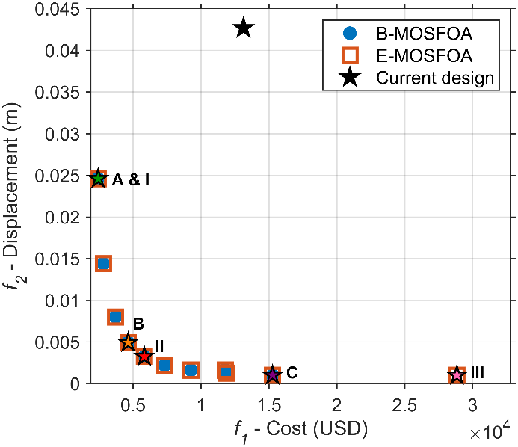 | 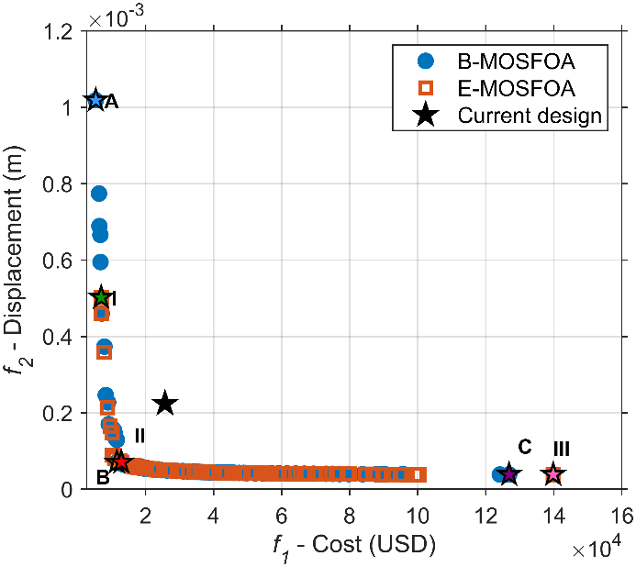
a) | b)
        - $PF$s for (a) MD and (b) MJP structures obtained by B-MOSFOA and E-MOSFOA, compared with current designs.
In addition, the two proposed algorithms return identical design variables and objective values at A/I and B/II. Thus, in these runs, both methods lead to the same minimum-cost and compromise BD alternatives. At the minimum-displacement endpoint, C and III both attain 0.003496 m; however, C costs USD 41,491.17 compared with USD 59,924.15 for III. B-MOSFOA therefore provides the less costly solution at the same reported displacement.
The same selection rule is then applied to MD and MJP. Fig. 10 compares their final archives, and Tables 11 and 12 report the corresponding representative designs. For MD, both algorithms return the same minimum-cost design A/I. A/I reduces cost by 81.5% and displacement by 42.4%. The compromise designs differ: B reduces cost and displacement by 64.7% and 88.4%, respectively, whereas II reduces them by 55.6% and 92.4%, respectively. At the minimum-displacement end, C and III both reduce displacement by 97.6%; C costs 47.1% less than III. Thus, II favors stiffness over cost at the compromise region, while C provides the more economical stiffness endpoint.
- Representative optimized MD designs and the current design.
Algorithm | Design | Pile type ($D_{p}$×$t_{p}$; $P_{p}$ (USD/m)) | $n$ | $L$ (m) | $f_{1}$ (USD) | $f_{2}$ (m)
B-MOSFOA | A | 450-A (0.45×0.07; 16.82) | 7 | 16.0 | 2,422.23 | 0.02459
 | B | 700-A (0.70×0.10; 32.16) | 6 | 16.0 | 4,630.61 | 0.004941
 | C | 1200-A (1.20×0.15; 100.95) | 6 | 16.8 | 15,263.70 | 0.001003
E-MOSFOA | I | 450-A (0.45×0.07; 16.82) | 7 | 16.0 | 2,422.23 | 0.02459
 | II | 800-A (0.80×0.11; 40.42) | 6 | 16.0 | 5,821.09 | 0.003261
 | III | 1200-C (1.20×0.15; 190.72) | 6 | 16.8 | 28,836.83 | 0.001003
Current design | - | 600-B (0.60×0.09; 38) | 6 | 39.0 | 13,121.12 | 0.04268
- Representative optimized MJP designs and current design.
Algorithm | Design | Pile type ($D_{p}$×$t_{p}$; $P_{p}$ (USD/m)) | $L_{p}$ (m) | $l_{1}$  (m) | $l_{2}$  (m) | $b$×$h$ (m) | $f_{1}$ (USD) | $f_{2}$ (m)
B-MOSFOA | A | 300-A (0.30×0.06; 8.12) | 38.7 | 5.3 | 5.6 | 0.5×0.5 | 5,350.32 | 0.001019
 | B | 300-A (0.30×0.06; 8.12) | 19.9 | 3.0 | 3.0 | 0.8×0.5 | 11,539.33 | 0.00007103
 | C | 1200-B (1.20×0.15; 163.16) | 16.8 | 3.0 | 3.0 | 1.4×2.0 | 126,865.66 | 0.00003877
E-MOSFOA | I | 300-A (0.30×0.06; 8.12) | 37.4 | 5.3 | 3.7 | 0.5×0.5 | 6,935.46 | 0.0005024
 | II | 300-B (0.30×0.06; 10.56) | 19.8 | 3.0 | 3.0 | 0.8×0.5 | 12,866.98 | 0.00007101
 | III | 1200-C (1.20×0.15; 190.72) | 16.8 | 3.0 | 3.0 | 1.4×2.0 | 139,831.48 | 0.00003877
Current design | - | 500-B (0.50×0.08; 27.26) | 38.0 | 4.2 | 4.5 | 0.7×1.0 | 25,708.94 | 0.0002244
Table 12 distinguishes three types of MJP design. A and I give the lowest costs, but their displacements (0.001019 and 0.0005024 m) exceed that of the current design (0.0002244 m); their cost reductions are therefore accompanied by lower structural stiffness. B and II improve both objectives: they reduce costs by 55.1% and 50.0%, and displacement by 68.3% and 68.4%, respectively. C and III give the smallest displacement, with both achieving an 82.7% reduction, but their costs are 4.93 and 5.44 times that of the current design. At the same reported displacement, C costs 9.3% less than III. Accordingly, A/I are cost-oriented alternatives, B/II provide balanced alternatives, and C/III are stiffness-oriented alternatives.
The results in Tables 10-12 describe the cost-displacement trade-off through representative designs. However, comparisons based solely on selected designs do not indicate whether the improvements are achieved with comparable computational effort or whether every solution in the final archives satisfies the constraints. Table 13, therefore, extends the assessment from representative designs to the complete final archives. It summarizes function evaluations, computation time, normalized $HV$, the number of feasible solutions relative to archive size, and the governing utilization ratios, allowing computational performance and archive-wide feasibility to be examined together.
In Table 13, feasible/archive gives the number of members satisfying $P(X)=0$ and all hard pre-analysis checks relative to the final archive size. The reported utilization ratios are $η_{M,max}=\max_{X∈A_{f}}{\frac{\max\left(\left|M_{2}^{FEA}\right|,\left|M_{3}^{FEA}\right|\right)}{M_{c,r}}}$, $η_{N,max}=\max_{X∈A_{f}}{\frac{\left|R_{z}^{FEA}\right|}{N_{c,d}}}$, and $η_{U,max}=\max_{X∈A_{f}}{\frac{U_{d}}{U_{r}}}$ where $A_{f}$ is the final archive and the maxima include all applicable piles (values not exceeding 1.0 satisfy the corresponding resistance limit).
- Computational effort, Pareto-set quality, and final-archive feasibility.
Case | Algorithm | FEs | Computation time (h) | Feasible/archive | $HV$ | $η_{M,max}$ | $η_{N,max}$ | $η_{U,max}$
BD | B-MOSFOA | 30,100 | 12.92 | 7/7 | 1.0833 | 0.7854 | 0.9908 | 0.0108
 | E-MOSFOA | 30,100 | 12.87 | 9/9 | 1.0833 | 0.7854 | 0.9908 | 0.0108
MD | B-MOSFOA | 30,100 | 6.91 | 9/9 | 1.1450 | 0.9971 | 0.9486 | 0.0495
 | E-MOSFOA | 30,100 | 6.73 | 10/10 | 1.1450 | 0.9971 | 0.9486 | 0.0495
MJP | B-MOSFOA | 30,100 | 4.32 | 80/80 | 1.1836 | 0.9930 | 0.9955 | -
 | E-MOSFOA | 30,100 | 5.09 | 100/100 | 1.1735 | 0.9795 | 0.9955 | -
The archive-wide records in Table 13 confirm that the feasible count equals the final archive size in all six assessments. The governing utilization is axial compression for BD (0.9908), pile bending for MD (0.9971), and axial compression for MJP (0.9955), with the corresponding secondary MJP bending ratio equal to 0.9930. Uplift utilization remains low for BD and MD (0.0108 and 0.0495, respectively) and does not apply to MJP. Thus, all final archives satisfy the implemented hard conditions and pile-resistance limits; the controlling ratios approach, but do not exceed unity.
Computational effort is compared at the same 30,100 evaluations per algorithm-case pair. B-MOSFOA and E-MOSFOA require similar computation times for BD (12.92 and 12.87 h) and MD (6.91 and 6.73 h). For MJP, B-MOSFOA completes at 4.32 h and attains a slightly larger normalized HV than E-MOSFOA (1.1836 versus 1.1735), while E-MOSFOA reaches the 100-member archive capacity in 5.09 h. Hence, the larger E-MOSFOA archive does not translate into a larger $HV$ in this single-run assessment. Because each algorithm-case pair is represented by one complete engineering run, the time and $HV$ results are descriptive and should not be interpreted as statistical superiority.
  - Conclusions, Limitations, and Future Work
This study extends SFOA to multi-objective design with B-MOSFOA, which introduces Pareto-archiving and density-based leader selection, and E-MOSFOA, which adds adaptive search and final-stage refinement. Across 104 problem-indicator combinations, E-MOSFOA and B-MOSFOA rank second (2.58) and third (2.75), close to MOMSA (2.52); B-MOSFOA also gives the best IMOP suite rank (2.28). The two variants, therefore, show competitive and complementary performance rather than universal dominance. For BD, MD, and MJP, the MATLAB-SAP2000 procedure identifies feasible Pareto sets that quantify the trade-off between construction cost and displacement. Lower-cost designs generally use smaller or shorter piles, whereas stiffer designs require heavier sections and higher expenditure. All six final archives satisfy the implemented constraints, with a maximum utilization ratio of 0.9971.
Limitations: In this research, two limitations remain. First, pile resistance and lateral restraint are represented using conventional code-based calculations and equivalent guided-and-roller supports. Although this approach is consistent with the adopted design standards, it does not fully capture nonlinear soil-pile interaction or soil-mediated pile-group effects. Second, evaluating every candidate through SAP2000 entails substantial computational cost.
Future Work: Further research should examine higher-fidelity soil-structure interaction models and reduce full SAP2000 evaluations through surrogate models or adaptive sampling. Besides, as a practical recommendation, the reference unit-price dataset is consistently applied to every candidate and algorithm, thereby preserving the internal consistency of the methodological comparison. Project applications should replace these reference values with current quotations for the relevant location, procurement period, and contract conditions.

Author Contributions
Thanh Do-Quang: Methodology, Software, Investigation, Writing – Original draft preparation; T. Vu-Huu: Conceptualization, Investigation, Validation and Editing;
Thanh Cuong-Le: Conceptualization, Writing - Review & Editing.
Data Availability Statement: The data supporting the findings of this study are available from the corresponding author upon reasonable request. Project records containing third-party material remain subject to the permissions of their respective owners.

Appendix A
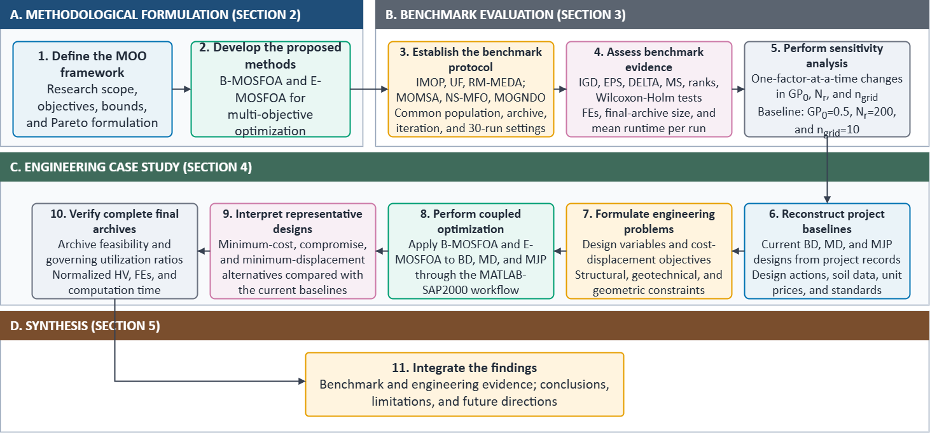
- Overall research workflow for algorithm development, benchmark evaluation, and marine-jetty design optimization.
- Full parameter sensitivity results.
Algorithm | Problem | $$GP_{0}$$ | $$N_{r}$$ | $$n_{grid}$$ | Mean $IGD$ | Mean $ε$ | Mean $Δ$ | Mean $MS$ | Runtime/run (s)
B-MOSFOA | IMOP1 | 0.5 | 200 | 10 | 0.01551 | 0.5835 | 1.117 | 0.7536 | 4.90
 |  | 0.3 | 200 | 10 | 0.01594 | 0.5756 | 1.109 | 0.6285 | 2.50
 |  | 0.5 | 100 | 10 | 0.01657 | 0.6169 | 1.085 | 0.7662 | 2.74
 |  | 0.5 | 200 | 15 | 0.01855 | 0.6709 | 1.080 | 0.5604 | 2.52
 |  | 0.5 | 200 | 5 | 0.01988 | 0.7448 | 1.079 | 0.5992 | 2.60
 |  | 0.5 | 300 | 10 | 0.01672 | 0.6168 | 1.097 | 0.7003 | 2.60
 |  | 0.7 | 200 | 10 | 0.02050 | 0.7511 | 1.064 | 0.5858 | 3.19
 | IMOP4 | 0.5 | 200 | 10 | 0.02897 | 1.046 | 1.291 | 1.707 | 6.92
 |  | 0.3 | 200 | 10 | 0.02679 | 0.9709 | 1.319 | 1.625 | 5.31
 |  | 0.5 | 100 | 10 | 0.02900 | 1.046 | 1.315 | 1.676 | 5.02
 |  | 0.5 | 200 | 15 | 0.02889 | 1.036 | 1.330 | 1.642 | 5.01
 |  | 0.5 | 200 | 5 | 0.03163 | 1.132 | 1.216 | 1.918 | 5.20
 |  | 0.5 | 300 | 10 | 0.02941 | 1.062 | 1.283 | 1.714 | 4.97
 |  | 0.7 | 200 | 10 | 0.03223 | 1.139 | 1.259 | 1.850 | 5.07
 | RMMEDA_F1 | 0.5 | 200 | 10 | 0.0001667 | 0.01124 | 0.2813 | 1.000 | 33.01
 |  | 0.3 | 200 | 10 | 0.0001385 | 0.009562 | 0.2673 | 1.000 | 35.77
 |  | 0.5 | 100 | 10 | 0.0002185 | 0.01409 | 0.2642 | 1.000 | 19.11
 |  | 0.5 | 200 | 15 | 0.0001499 | 0.01007 | 0.2728 | 1.000 | 33.49
 |  | 0.5 | 200 | 5 | 0.0001551 | 0.01112 | 0.2869 | 1.000 | 31.59
 |  | 0.5 | 300 | 10 | 0.0001559 | 0.01082 | 0.3493 | 1.000 | 48.48
 |  | 0.7 | 200 | 10 | 0.0002490 | 0.01616 | 0.3484 | 1.000 | 29.21
 | RMMEDA_F4 | 0.5 | 200 | 10 | 0.001673 | 0.09187 | 0.6283 | 1.139 | 60.23
 |  | 0.3 | 200 | 10 | 0.001646 | 0.09096 | 0.6316 | 1.044 | 64.91
 |  | 0.5 | 100 | 10 | 0.002363 | 0.1184 | 0.6310 | 1.058 | 32.68
 |  | 0.5 | 200 | 15 | 0.001649 | 0.09508 | 0.6302 | 1.049 | 63.49
 |  | 0.5 | 200 | 5 | 0.001657 | 0.09540 | 0.6302 | 1.020 | 56.60
 |  | 0.5 | 300 | 10 | 0.001345 | 0.07773 | 0.6238 | 1.045 | 92.57
 |  | 0.7 | 200 | 10 | 0.001657 | 0.09226 | 0.6237 | 1.044 | 54.34
 | UF3 | 0.5 | 200 | 10 | 0.01157 | 0.3525 | 1.073 | 1.000 | 40.72
 |  | 0.3 | 200 | 10 | 0.01168 | 0.3572 | 1.090 | 1.000 | 41.42
 |  | 0.5 | 100 | 10 | 0.01167 | 0.3605 | 1.012 | 1.000 | 21.92
 |  | 0.5 | 200 | 15 | 0.01150 | 0.3490 | 1.066 | 1.000 | 37.63
 |  | 0.5 | 200 | 5 | 0.01199 | 0.3807 | 1.193 | 1.000 | 39.13
 |  | 0.5 | 300 | 10 | 0.01179 | 0.3608 | 1.185 | 1.000 | 59.90
 |  | 0.7 | 200 | 10 | 0.01171 | 0.3630 | 1.133 | 1.000 | 33.52
 | UF8 | 0.5 | 200 | 10 | 0.01357 | 0.7362 | 1.339 | 2.179 | 21.62
 |  | 0.3 | 200 | 10 | 0.01469 | 0.7113 | 1.336 | 2.226 | 25.59
 |  | 0.5 | 100 | 10 | 0.01462 | 0.7352 | 1.089 | 1.954 | 16.45
 |  | 0.5 | 200 | 15 | 0.01431 | 0.7478 | 1.349 | 1.911 | 21.38
 |  | 0.5 | 200 | 5 | 0.01474 | 0.7471 | 1.417 | 2.365 | 20.24
 |  | 0.5 | 300 | 10 | 0.01361 | 0.7163 | 1.485 | 1.903 | 23.98
 |  | 0.7 | 200 | 10 | 0.01376 | 0.7275 | 1.343 | 2.144 | 16.51
E-MOSFOA | IMOP1 | 0.5 | 200 | 10 | 0.005999 | 0.02769 | 1.218 | 0.8403 | 16.25
 |  | 0.3 | 200 | 10 | 0.006324 | 0.03981 | 1.198 | 0.8342 | 7.09
 |  | 0.5 | 100 | 10 | 0.006090 | 0.02911 | 1.143 | 0.8454 | 11.79
 |  | 0.5 | 200 | 15 | 0.005822 | 0.02944 | 1.206 | 0.8554 | 13.36
 |  | 0.5 | 200 | 5 | 0.006061 | 0.02482 | 1.223 | 0.8383 | 15.04
 |  | 0.5 | 300 | 10 | 0.006047 | 0.03083 | 1.214 | 0.8403 | 12.88
 |  | 0.7 | 200 | 10 | 0.005661 | 0.02099 | 1.152 | 0.8509 | 21.91
 | IMOP4 | 0.5 | 200 | 10 | 0.006628 | 0.3075 | 0.9741 | 1.042 | 10.35
 |  | 0.3 | 200 | 10 | 0.007051 | 0.3319 | 1.051 | 1.063 | 8.56
 |  | 0.5 | 100 | 10 | 0.006223 | 0.2901 | 0.9418 | 1.035 | 9.75
 |  | 0.5 | 200 | 15 | 0.006113 | 0.2858 | 0.9578 | 1.031 | 10.09
 |  | 0.5 | 200 | 5 | 0.006022 | 0.2831 | 0.9707 | 1.035 | 9.04
 |  | 0.5 | 300 | 10 | 0.006472 | 0.3027 | 0.9829 | 1.042 | 8.95
 |  | 0.7 | 200 | 10 | 0.009210 | 0.3918 | 1.015 | 1.135 | 8.96
 | RMMEDA_F1 | 0.5 | 200 | 10 | 0.0001225 | 0.009078 | 0.2625 | 1.000 | 41.83
 |  | 0.3 | 200 | 10 | 0.0001339 | 0.008553 | 0.2550 | 1.000 | 41.23
 |  | 0.5 | 100 | 10 | 0.0002499 | 0.02046 | 0.3198 | 1.000 | 23.98
 |  | 0.5 | 200 | 15 | 0.0001231 | 0.008492 | 0.2647 | 1.000 | 41.34
 |  | 0.5 | 200 | 5 | 0.0001206 | 0.008335 | 0.2576 | 1.000 | 40.06
 |  | 0.5 | 300 | 10 | 0.00009187 | 0.005767 | 0.2489 | 1.000 | 71.50
 |  | 0.7 | 200 | 10 | 0.0001194 | 0.009122 | 0.2758 | 1.000 | 40.71
 | RMMEDA_F4 | 0.5 | 200 | 10 | 0.001813 | 0.09989 | 0.6166 | 1.003 | 62.02
 |  | 0.3 | 200 | 10 | 0.001808 | 0.1061 | 0.6289 | 1.003 | 63.68
 |  | 0.5 | 100 | 10 | 0.002500 | 0.1225 | 0.5978 | 1.004 | 34.64
 |  | 0.5 | 200 | 15 | 0.001782 | 0.09202 | 0.6135 | 1.003 | 66.27
 |  | 0.5 | 200 | 5 | 0.001824 | 0.09978 | 0.6125 | 1.005 | 60.04
 |  | 0.5 | 300 | 10 | 0.001513 | 0.08638 | 0.6193 | 1.003 | 109.69
 |  | 0.7 | 200 | 10 | 0.001802 | 0.09800 | 0.6100 | 1.003 | 60.18
 | UF3 | 0.5 | 200 | 10 | 0.01038 | 0.3166 | 1.489 | 1.000 | 35.15
 |  | 0.3 | 200 | 10 | 0.01083 | 0.3395 | 1.424 | 1.000 | 42.07
 |  | 0.5 | 100 | 10 | 0.01041 | 0.3162 | 1.179 | 1.000 | 20.93
 |  | 0.5 | 200 | 15 | 0.01036 | 0.3158 | 1.480 | 1.000 | 36.65
 |  | 0.5 | 200 | 5 | 0.01056 | 0.3229 | 1.496 | 1.000 | 36.43
 |  | 0.5 | 300 | 10 | 0.01037 | 0.3152 | 1.631 | 1.000 | 53.32
 |  | 0.7 | 200 | 10 | 0.009454 | 0.3002 | 1.632 | 1.000 | 27.76
 | UF8 | 0.5 | 200 | 10 | 0.01708 | 0.7167 | 0.7792 | 0.9083 | 35.49
 |  | 0.3 | 200 | 10 | 0.01550 | 0.7433 | 1.046 | 1.032 | 31.72
 |  | 0.5 | 100 | 10 | 0.01675 | 0.7211 | 0.7145 | 0.9106 | 21.72
 |  | 0.5 | 200 | 15 | 0.01856 | 0.7179 | 0.7039 | 0.8886 | 37.30
 |  | 0.5 | 200 | 5 | 0.01438 | 0.6975 | 0.8680 | 1.231 | 33.35
 |  | 0.5 | 300 | 10 | 0.01738 | 0.7167 | 0.8272 | 0.9321 | 48.68
 |  | 0.7 | 200 | 10 | 0.01825 | 0.7097 | 0.7492 | 0.9856 | 39.73

- Detailed indicator results on IMOP benchmarks after statistical revision.
IMOP | Statistical Keys | $IGD$ |  |  |  |  | $ε$ |  |  |  |  | $Δ$ |  |  |  |  | $MS$
 |  | A1 | A2 | A3 | A4 | A5 | A1 | A2 | A3 | A4 | A5 | A1 | A2 | A3 | A4 | A5 | A1 | A2 | A3 | A4 | A5
1 | Best | 0.01544 | 0.02203 | 0.02818 | 0.00720 | 0.00439 | 0.34478 | 0.72280 | 0.98340 | 0.18023 | 0.00454 | 0.94806 | 0.94530 | 0.99957 | 0.89116 | 1.04795 | 0.40996 | 0.15129 | 0.00363 | 1.03968 | 0.91271
 | Mean | 0.01651 | 0.02379 | 0.02829 | 0.01233 | 0.00582 | 0.42157 | 0.80154 | 0.98712 | 0.45221 | 0.02638 | 1.00636 | 1.00213 | 0.99993 | 1.12925 | 1.15819 | 0.26314 | 0.04840 | 0.00099 | 0.84844 | 0.85172
 | Std | 0.00067 | 0.00079 | 2.95E-5 | 0.00691 | 0.00055 | 0.04469 | 0.03487 | 0.00100 | 0.25463 | 0.01404 | 0.03825 | 0.01850 | 0.00025 | 0.10149 | 0.03493 | 0.09380 | 0.03934 | 0.00070 | 0.33795 | 0.02533
 | Rank | 3 | 4 | 5 | 2 | 1 | 2 | 4 | 5 | 3 | 1 | 3 | 2 | 1 | 4 | 5 | 3 | 4 | 5 | 2 | 1
 | Wilcoxon | + | + | + | + | Ref. | + | + | + | + | Ref. | - | - | - | = | Ref. | + | + | + | - | Ref.
2 | Best | 0.01733 | 0.02260 | 0.02278 | 0.01143 | 0.02810 | 0.98442 | 1.00113 | 0.99930 | 0.38354 | 1.00000 | 0.93279 | 0.95357 | 0.98888 | 0.95773 | 1.00000 | 0.34346 | 0.11703 | 0.04604 | 0.91520 | 5.17E-5
 | Mean | 0.01933 | 0.02421 | 0.02293 | 0.02467 | 0.02810 | 0.99300 | 1.00256 | 1.00138 | 0.99289 | 1.00000 | 0.98082 | 0.99710 | 0.99604 | 0.99514 | 1.00000 | 0.27118 | 0.06236 | 0.02501 | 0.07715 | 2.01E-6
 | Std | 0.00171 | 0.00107 | 0.00015 | 0.00272 | 3.31E-7 | 0.00419 | 0.00108 | 0.00295 | 0.11527 | 1.29E-7 | 0.03468 | 0.01804 | 0.00439 | 0.06985 | 2.61E-6 | 0.05721 | 0.03160 | 0.00839 | 0.16032 | 9.43E-6
 | Rank | 1 | 3 | 2 | 4 | 5 | 2 | 5 | 4 | 1 | 3 | 1 | 4 | 3 | 2 | 5 | 1 | 3 | 4 | 2 | 5
 | Wilcoxon | - | - | - | - | Ref. | - | + | = | + | Ref. | - | = | - | - | Ref. | - | - | - | - | Ref.
3 | Best | 0.03537 | 0.04603 | 0.04933 | 0.01939 | 0.01435 | 0.74226 | 0.86500 | 0.95455 | 0.59346 | 0.46932 | 0.84469 | 0.93545 | 0.98544 | 0.55408 | 0.99731 | 0.28788 | 0.10902 | 0.05925 | 1.01841 | 0.99886
 | Mean | 0.03620 | 0.05042 | 0.05043 | 0.02636 | 0.01713 | 0.78050 | 0.88430 | 0.96074 | 0.70377 | 0.53702 | 0.90574 | 0.97890 | 0.99617 | 1.08622 | 1.57929 | 0.26334 | 0.04718 | 0.02181 | 0.98727 | 0.96803
 | Std | 0.00086 | 0.00164 | 0.00076 | 0.00575 | 0.00468 | 0.01385 | 0.00794 | 0.00258 | 0.08931 | 0.04323 | 0.02706 | 0.01752 | 0.00458 | 0.18993 | 0.12476 | 0.02106 | 0.02242 | 0.01352 | 0.00777 | 0.14791
 | Rank | 3 | 4 | 5 | 2 | 1 | 3 | 4 | 5 | 2 | 1 | 1 | 2 | 3 | 4 | 5 | 3 | 4 | 5 | 1 | 2
 | Wilcoxon | + | + | + | + | Ref. | + | + | + | + | Ref. | - | - | - | - | Ref. | + | + | + | + | Ref.
4 | Best | 0.01852 | 0.00574 | 0.01606 | 0.00328 | 0.00352 | 0.70688 | 0.25534 | 0.60133 | 0.18634 | 0.17697 | 0.79863 | 1.03782 | 0.91523 | 1.04910 | 0.97507 | 0.70316 | 1.76696 | 1.27450 | 1.04695 | 1.01555
 | Mean | 0.02184 | 0.01023 | 0.02777 | 0.00699 | 0.00622 | 0.80346 | 0.42567 | 0.94288 | 0.31682 | 0.27351 | 0.92033 | 1.28627 | 1.00006 | 1.15146 | 1.04076 | 0.32880 | 1.50625 | 0.25435 | 1.02138 | 1.00244
 | Std | 0.00171 | 0.00181 | 0.00310 | 0.00134 | 0.00078 | 0.04337 | 0.06114 | 0.08359 | 0.04691 | 0.02835 | 0.09152 | 0.10474 | 0.15037 | 0.05015 | 0.03337 | 0.13420 | 0.17590 | 0.34505 | 0.01114 | 0.00305
 | Rank | 4 | 3 | 5 | 2 | 1 | 4 | 3 | 5 | 2 | 1 | 1 | 5 | 2 | 4 | 3 | 4 | 1 | 5 | 2 | 3
 | Wilcoxon | + | + | + | + | Ref. | + | + | + | + | Ref. | - | + | - | + | Ref. | + | - | + | - | Ref.
5 | Best | 0.01135 | 0.01235 | 0.01294 | 0.00353 | 0.01093 | 0.43222 | 0.50721 | 0.56417 | 0.18889 | 0.39366 | 0.65807 | 0.76013 | 0.66289 | 0.70373 | 0.66331 | 0.71161 | 0.69313 | 0.63830 | 0.87165 | 0.76520
 | Mean | 0.01306 | 0.01406 | 0.02278 | 0.00866 | 0.01120 | 0.49195 | 0.60324 | 0.83787 | 0.36639 | 0.41952 | 0.76513 | 0.89111 | 0.89128 | 0.79194 | 0.73573 | 0.60435 | 0.57583 | 0.21035 | 0.78009 | 0.72139
 | Std | 0.00072 | 0.00075 | 0.00408 | 0.00263 | 0.00016 | 0.04933 | 0.04903 | 0.09973 | 0.07536 | 0.02676 | 0.04356 | 0.04678 | 0.11818 | 0.07122 | 0.03494 | 0.04751 | 0.06843 | 0.15951 | 0.05370 | 0.02449
 | Rank | 3 | 4 | 5 | 1 | 2 | 3 | 4 | 5 | 1 | 2 | 2 | 4 | 5 | 3 | 1 | 3 | 4 | 5 | 1 | 2
 | Wilcoxon | + | + | + | - | Ref. | + | + | + | - | Ref. | + | + | + | + | Ref. | + | + | + | - | Ref.
6 | Best | 0.01914 | 0.02087 | 0.01661 | 0.00539 | 0.00880 | 0.38879 | 0.35607 | 0.34308 | 0.17283 | 0.18299 | 0.64137 | 0.78586 | 0.71311 | 0.62342 | 0.60249 | 1.97593 | 1.75274 | 2.15338 | 1.17442 | 1.02034
 | Mean | 0.02495 | 0.02422 | 0.03045 | 0.00982 | 0.01006 | 0.70071 | 0.48233 | 0.81770 | 0.22261 | 0.22253 | 0.79020 | 0.90070 | 1.06554 | 0.70406 | 0.68183 | 0.90660 | 1.45968 | 1.20835 | 1.07344 | 1.00786
 | Std | 0.00267 | 0.00107 | 0.00528 | 0.00135 | 0.00263 | 0.09359 | 0.08250 | 0.19710 | 0.02593 | 0.05946 | 0.06110 | 0.04093 | 0.20235 | 0.03979 | 0.04328 | 0.27791 | 0.15583 | 0.46057 | 0.03569 | 0.00500
 | Rank | 4 | 3 | 5 | 1 | 2 | 4 | 3 | 5 | 2 | 1 | 3 | 4 | 5 | 2 | 1 | 5 | 1 | 2 | 3 | 4
 | Wilcoxon | + | + | + | + | Ref. | + | + | + | = | Ref. | + | + | + | + | Ref. | + | - | = | - | Ref.
7 | Best | 0.04001 | 0.02150 | 0.04453 | 0.01528 | 0.01046 | 0.92405 | 0.37884 | 0.99792 | 0.24570 | 0.22106 | 0.68538 | 0.83769 | 0.83919 | 0.85826 | 0.70348 | 0.99127 | 1.91146 | 1.68876 | 1.09099 | 1.38789
 | Mean | 0.04252 | 0.02772 | 0.05245 | 0.01717 | 0.03389 | 0.94747 | 0.57286 | 1.00065 | 0.29329 | 0.74784 | 0.77925 | 1.06062 | 1.06201 | 1.24977 | 1.30803 | 0.38202 | 1.46621 | 0.44704 | 1.04484 | 1.03354
 | Std | 0.00112 | 0.00485 | 0.00193 | 0.00115 | 0.01229 | 0.01015 | 0.19319 | 0.00536 | 0.02434 | 0.29589 | 0.05944 | 0.08951 | 0.12255 | 0.11233 | 0.23827 | 0.13913 | 0.18282 | 0.40543 | 0.02573 | 0.18354
 | Rank | 4 | 2 | 5 | 1 | 3 | 4 | 2 | 5 | 1 | 3 | 1 | 2 | 3 | 4 | 5 | 5 | 1 | 4 | 2 | 3
 | Wilcoxon | + | - | + | - | Ref. | = | - | + | - | Ref. | - | - | - | - | Ref. | + | - | + | = | Ref.
8 | Best | 0.02301 | 0.03159 | 0.03436 | 0.02099 | 0.01488 | 0.49542 | 0.63430 | 0.73837 | 0.49859 | 0.34130 | 0.66763 | 0.72507 | 0.61607 | 0.66474 | 0.58901 | 1.39706 | 1.02245 | 1.33149 | 1.01476 | 1.00716
 | Mean | 0.02948 | 0.03826 | 0.04074 | 0.02358 | 0.01782 | 0.62916 | 0.68623 | 0.82128 | 0.63324 | 0.46703 | 0.74093 | 0.80451 | 0.72258 | 0.73205 | 0.65138 | 1.30188 | 0.93613 | 1.11645 | 0.98172 | 0.98747
 | Std | 0.00316 | 0.00193 | 0.00677 | 0.00208 | 0.00107 | 0.06516 | 0.03430 | 0.19430 | 0.14514 | 0.08285 | 0.04427 | 0.04361 | 0.04480 | 0.03482 | 0.02750 | 0.04529 | 0.03658 | 0.09905 | 0.01967 | 0.01225
 | Rank | 3 | 4 | 5 | 2 | 1 | 2 | 4 | 5 | 3 | 1 | 4 | 5 | 2 | 3 | 1 | 1 | 5 | 2 | 4 | 3
 | Wilcoxon | + | + | + | + | Ref. | + | + | + | + | Ref. | + | + | + | + | Ref. | - | + | - | = | Ref.
Note. Algorithm columns under each metric use the fixed order A1-A5: A1=MOMSA, A2=NS-MFO, A3=MOGNDO, A4=B-MOSFOA, A5=E-MOSFOA. Statistical Keys denote Best, Mean, Std, Rank, and Wilcoxon. Symbols +, -, and = indicate that E-MOSFOA is statistically better than, worse than, or not significantly different from the compared algorithm, respectively; Ref. identifies the E-MOSFOA reference column.
- Detailed indicator results on UF benchmarks after statistical revision.
UF | Statistical Keys | $IGD$ |  |  |  |  | $ε$ |  |  |  |  | $Δ$ |  |  |  |  | $MS$
 |  | A1 | A2 | A3 | A4 | A5 | A1 | A2 | A3 | A4 | A5 | A1 | A2 | A3 | A4 | A5 | A1 | A2 | A3 | A4 | A5
1 | Best | 0.00273 | 0.00339 | 0.00575 | 0.00399 | 0.00238 | 0.13422 | 0.17863 | 0.24563 | 0.18554 | 0.10670 | 0.98649 | 1.43796 | 0.71222 | 0.59543 | 0.76326 | 1.89647 | 1.39721 | 1.21212 | 1.86216 | 1.31664
 | Mean | 0.00363 | 0.00420 | 0.00690 | 0.00509 | 0.00287 | 0.19716 | 0.23601 | 0.32074 | 0.22675 | 0.15111 | 1.25653 | 1.66074 | 0.99865 | 0.80280 | 0.95637 | 1.15032 | 1.00280 | 0.97272 | 1.24539 | 1.05885
 | Std | 0.00035 | 0.00021 | 0.00067 | 0.00049 | 0.00026 | 0.03791 | 0.01985 | 0.04415 | 0.02786 | 0.02596 | 0.11323 | 0.10872 | 0.11477 | 0.11353 | 0.11335 | 0.21985 | 0.17863 | 0.18274 | 0.26945 | 0.12927
 | Rank | 2 | 3 | 5 | 4 | 1 | 2 | 4 | 5 | 3 | 1 | 4 | 5 | 3 | 1 | 2 | 2 | 4 | 5 | 1 | 3
 | Wilcoxon | + | + | + | + | Ref. | + | + | + | + | Ref. | + | + | + | - | Ref. | = | + | = | - | Ref.
2 | Best | 0.00137 | 0.00284 | 0.00293 | 0.00291 | 0.00157 | 0.08058 | 0.15899 | 0.14625 | 0.14329 | 0.08199 | 0.46006 | 0.59474 | 0.63918 | 1.15351 | 0.89107 | 1.23442 | 1.28209 | 1.85771 | 1.78554 | 1.29754
 | Mean | 0.00162 | 0.00347 | 0.00333 | 0.00380 | 0.00186 | 0.10087 | 0.21435 | 0.17853 | 0.20069 | 0.10142 | 0.58011 | 0.82816 | 0.82849 | 1.33018 | 0.99840 | 1.08900 | 1.09994 | 1.42271 | 1.27562 | 1.10914
 | Std | 0.00012 | 0.00030 | 0.00021 | 0.00047 | 0.00013 | 0.01198 | 0.01930 | 0.01627 | 0.02620 | 0.00936 | 0.07678 | 0.08715 | 0.09442 | 0.07344 | 0.06214 | 0.05426 | 0.10371 | 0.19760 | 0.19090 | 0.07634
 | Rank | 1 | 4 | 3 | 5 | 2 | 1 | 5 | 3 | 4 | 2 | 1 | 2 | 3 | 5 | 4 | 5 | 4 | 1 | 2 | 3
 | Wilcoxon | - | + | + | + | Ref. | = | + | + | + | Ref. | - | - | - | + | Ref. | = | = | - | - | Ref.
3 | Best | 0.00804 | 0.00939 | 0.01142 | 0.01101 | 0.00799 | 0.26036 | 0.30618 | 0.35157 | 0.32676 | 0.27899 | 0.95598 | 0.84904 | 1 | 0.91361 | 1.34719 | 2.22602 | 1 | 1.33591 | 1 | 1
 | Mean | 0.00990 | 0.01019 | 0.01287 | 0.01167 | 0.00946 | 0.29244 | 0.33872 | 0.43785 | 0.35539 | 0.29792 | 1.10721 | 1.33915 | 1.60113 | 1.09338 | 1.63032 | 1.29862 | 1 | 0.91120 | 1 | 1
 | Std | 0.00083 | 0.00041 | 0.00323 | 0.00037 | 0.00069 | 0.01206 | 0.02589 | 0.19217 | 0.01547 | 0.00935 | 0.09371 | 0.33459 | 0.21092 | 0.09252 | 0.10712 | 0.32972 | 0 | 0.31493 | 0 | 0
 | Rank | 2 | 3 | 5 | 4 | 1 | 1 | 3 | 5 | 4 | 2 | 2 | 3 | 4 | 1 | 5 | 1 | 3 | 5 | 3 | 3
 | Wilcoxon | = | + | + | + | Ref. | = | + | + | + | Ref. | - | - | = | - | Ref. | - | n/a | = | n/a | Ref.
4 | Best | 0.00374 | 0.00287 | 0.00197 | 0.00169 | 0.00163 | 0.11213 | 0.12680 | 0.08662 | 0.05911 | 0.06078 | 0.67511 | 1.16957 | 0.60323 | 0.48938 | 0.48682 | 1.11491 | 1.02270 | 1.08324 | 1.07201 | 1.03958
 | Mean | 0.00391 | 0.00299 | 0.00295 | 0.00207 | 0.00191 | 0.11815 | 0.13375 | 0.11788 | 0.08082 | 0.07585 | 0.74131 | 1.25910 | 0.89291 | 0.72655 | 0.75359 | 1.06757 | 1.00414 | 1.02607 | 1.03007 | 1.01605
 | Std | 9.03E-5 | 6.26E-5 | 0.00039 | 0.00017 | 0.00016 | 0.00358 | 0.00381 | 0.01430 | 0.00590 | 0.00710 | 0.03439 | 0.04348 | 0.14456 | 0.09336 | 0.12874 | 0.02344 | 0.00662 | 0.02381 | 0.01530 | 0.01038
 | Rank | 5 | 4 | 3 | 2 | 1 | 4 | 5 | 3 | 2 | 1 | 2 | 5 | 4 | 1 | 3 | 1 | 5 | 3 | 2 | 4
 | Wilcoxon | + | + | + | + | Ref. | + | + | + | + | Ref. | = | + | + | = | Ref. | - | + | = | - | Ref.
5 | Best | 0.11829 | 0.08304 | 0.44929 | 0.26359 | 0.07493 | 0.61446 | 0.46513 | 1.73492 | 1.13581 | 0.52026 | 0.85710 | 0.89154 | 0.79313 | 0.73796 | 0.85678 | 2.75046 | 3.46901 | 2.27339 | 4.28868 | 2.13927
 | Mean | 0.23036 | 0.13230 | 0.51549 | 0.38203 | 0.17392 | 1.03457 | 0.74742 | 2.00741 | 1.52169 | 0.99368 | 0.97958 | 1.16363 | 0.86296 | 0.85271 | 1.07979 | 1.60912 | 1.43323 | 1.66016 | 2.56926 | 1.45011
 | Std | 0.06962 | 0.02957 | 0.03476 | 0.06998 | 0.06055 | 0.22991 | 0.17632 | 0.17586 | 0.21786 | 0.32560 | 0.06847 | 0.10368 | 0.04119 | 0.05727 | 0.10609 | 0.49068 | 0.57107 | 0.44130 | 0.73012 | 0.45402
 | Rank | 3 | 1 | 5 | 4 | 2 | 3 | 1 | 5 | 4 | 2 | 3 | 5 | 2 | 1 | 4 | 3 | 5 | 2 | 1 | 4
 | Wilcoxon | + | - | + | + | Ref. | = | - | + | + | Ref. | - | + | - | - | Ref. | = | = | = | - | Ref.
6 | Best | 0.01817 | 0.01750 | 0.03657 | 0.02442 | 0.00751 | 0.52078 | 0.47236 | 0.82041 | 0.57893 | 0.27255 | 0.92798 | 1.21505 | 0.76147 | 0.76912 | 0.87994 | 2.60678 | 2.61879 | 1.75534 | 5.56791 | 4.47558
 | Mean | 0.02358 | 0.01971 | 0.05133 | 0.03160 | 0.01829 | 0.60084 | 0.55840 | 1.18935 | 0.70277 | 0.49799 | 1.18257 | 1.39831 | 0.91141 | 0.90883 | 1.04082 | 1.41422 | 1.27661 | 0.88151 | 1.96385 | 1.17913
 | Std | 0.00340 | 0.00085 | 0.00515 | 0.00389 | 0.00440 | 0.09264 | 0.06728 | 0.25809 | 0.12370 | 0.15194 | 0.10449 | 0.07558 | 0.06372 | 0.08084 | 0.08116 | 0.58001 | 0.52774 | 0.38498 | 1.04529 | 0.71081
 | Rank | 3 | 2 | 5 | 4 | 1 | 3 | 2 | 5 | 4 | 1 | 4 | 5 | 2 | 1 | 3 | 2 | 3 | 5 | 1 | 4
 | Wilcoxon | + | = | + | + | Ref. | + | + | + | + | Ref. | + | + | - | - | Ref. | = | = | = | - | Ref.
7 | Best | 0.00238 | 0.00267 | 0.00533 | 0.00299 | 0.00162 | 0.15326 | 0.19592 | 0.28792 | 0.15385 | 0.08747 | 0.82538 | 1.08053 | 0.78039 | 0.59778 | 0.78648 | 1.43259 | 1.47406 | 1.34506 | 1.34981 | 1.27077
 | Mean | 0.00283 | 0.00415 | 0.00965 | 0.00413 | 0.00242 | 0.18620 | 0.25606 | 0.47667 | 0.20952 | 0.14967 | 0.99619 | 1.20772 | 0.90194 | 0.74706 | 0.97622 | 1.06385 | 1.03207 | 0.88797 | 1.19030 | 1.04071
 | Std | 0.00046 | 0.00298 | 0.00385 | 0.00064 | 0.00069 | 0.01356 | 0.12452 | 0.21853 | 0.02561 | 0.02298 | 0.07987 | 0.06590 | 0.07009 | 0.06777 | 0.12922 | 0.13242 | 0.23130 | 0.36094 | 0.07333 | 0.05834
 | Rank | 2 | 4 | 5 | 3 | 1 | 2 | 4 | 5 | 3 | 1 | 4 | 5 | 2 | 1 | 3 | 2 | 4 | 5 | 1 | 3
 | Wilcoxon | + | + | + | + | Ref. | + | + | + | + | Ref. | = | + | = | - | Ref. | = | = | = | - | Ref.
8 | Best | 0.01130 | 0.01120 | 0.00870 | 0.00906 | 0.01102 | 0.70792 | 0.70726 | 0.33745 | 0.36826 | 0.65192 | 0.61773 | 0.60807 | 0.66600 | 0.93771 | 0.65318 | 3.32057 | 2.95364 | 4.52971 | 11.01168 | 1.05376
 | Mean | 0.01141 | 0.01156 | 0.01202 | 0.01537 | 0.01761 | 0.71466 | 0.70927 | 0.63450 | 0.69121 | 0.71088 | 0.69875 | 0.66669 | 0.86618 | 1.39001 | 0.73531 | 2.71572 | 2.26413 | 1.59104 | 2.56107 | 0.84665
 | Std | 7.72E-5 | 0.00033 | 0.00224 | 0.00363 | 0.00218 | 0.00677 | 0.00267 | 0.12299 | 0.14103 | 0.01127 | 0.04203 | 0.03259 | 0.13936 | 0.17584 | 0.08301 | 0.32792 | 0.44348 | 0.71149 | 2.27949 | 0.04824
 | Rank | 1 | 2 | 3 | 4 | 5 | 5 | 3 | 1 | 2 | 4 | 2 | 1 | 4 | 5 | 3 | 1 | 3 | 4 | 2 | 5
 | Wilcoxon | - | - | - | - | Ref. | = | - | = | + | Ref. | = | - | + | + | Ref. | - | - | - | - | Ref.
9 | Best | 0.00845 | 0.00495 | 0.01518 | 0.01652 | 0.01121 | 0.25353 | 0.16716 | 0.43336 | 0.45800 | 0.32859 | 0.82197 | 0.79823 | 0.55817 | 0.84267 | 0.64937 | 6.12593 | 3.58862 | 3.84660 | 11.50925 | 6.99851
 | Mean | 0.01454 | 0.01131 | 0.02160 | 0.02387 | 0.01803 | 0.44153 | 0.36977 | 0.60308 | 0.66804 | 0.52548 | 0.94193 | 1.01218 | 0.86934 | 1.16722 | 0.88616 | 4.02457 | 1.70767 | 2.20514 | 6.35779 | 3.12729
 | Std | 0.00291 | 0.00610 | 0.00435 | 0.00352 | 0.00356 | 0.08759 | 0.17145 | 0.12074 | 0.10527 | 0.10858 | 0.07098 | 0.09961 | 0.17339 | 0.16333 | 0.16269 | 0.86385 | 0.62299 | 0.66919 | 2.64436 | 1.22238
 | Rank | 2 | 1 | 4 | 5 | 3 | 2 | 1 | 4 | 5 | 3 | 3 | 4 | 1 | 5 | 2 | 2 | 5 | 4 | 1 | 3
 | Wilcoxon | - | - | + | + | Ref. | - | - | = | + | Ref. | + | + | = | + | Ref. | - | + | + | - | Ref.
Note. Algorithm columns under each metric use the fixed order A1-A5: A1=MOMSA, A2=NS-MFO, A3=MOGNDO, A4=B-MOSFOA, A5=E-MOSFOA. Statistical Keys denote Best, Mean, Std, Rank, and Wilcoxon. Symbols +, -, and = indicate that E-MOSFOA is statistically better than, worse than, or not significantly different from the compared algorithm, respectively; Ref. identifies the E-MOSFOA reference column.
- Detailed indicator results on RM-MEDA benchmarks after statistical revision.
RM-MEDA | Statistical  Keys | $IGD$ |  |  |  |  | $ε$ |  |  |  |  | $Δ$ |  |  |  |  | $MS$
 |  | A1 | A2 | A3 | A4 | A5 | A1 | A2 | A3 | A4 | A5 | A1 | A2 | A3 | A4 | A5 | A1 | A2 | A3 | A4 | A5
F1 | Best | 9.44E-5 | 9.99E-5 | 0.00034 | 8.74E-5 | 0.00012 | 0.00543 | 0.00632 | 0.02148 | 0.00555 | 0.00722 | 0.23920 | 0.22883 | 1.00024 | 0.22237 | 0.23786 | 2.55144 | 1 | 1 | 1 | 1
 | Mean | 0.00010 | 0.00011 | 0.00040 | 0.00013 | 0.00012 | 0.00702 | 0.00743 | 0.02900 | 0.00907 | 0.00932 | 0.76027 | 0.26323 | 1.09180 | 0.26558 | 0.26492 | 1.67586 | 1 | 1 | 1 | 1
 | Std | 6.56E-6 | 3.74E-6 | 4.98E-5 | 2.90E-5 | 2.78E-6 | 0.00164 | 0.00094 | 0.00557 | 0.00194 | 0.00144 | 0.34983 | 0.01708 | 0.06238 | 0.01977 | 0.01497 | 0.55385 | 0 | 0 | 0 | 0
 | Rank | 1 | 2 | 5 | 4 | 3 | 1 | 2 | 5 | 3 | 4 | 4 | 1 | 5 | 3 | 2 | 1 | 3.5 | 3.5 | 3.5 | 3.5
 | Wilcoxon | - | - | + | = | Ref. | - | - | + | = | Ref. | + | = | + | = | Ref. | - | = | = | = | Ref.
F2 | Best | 9.11E-5 | 0.00010 | 0.00057 | 8.37E-5 | 0.00011 | 0.00637 | 0.00605 | 0.02508 | 0.00552 | 0.00663 | 0.23479 | 0.23618 | 1.15063 | 0.28422 | 0.25364 | 4.29536 | 1 | 1 | 1 | 1
 | Mean | 0.00012 | 0.00013 | 0.00082 | 9.66E-5 | 0.00013 | 0.01485 | 0.00703 | 0.03555 | 0.00731 | 0.00795 | 0.57571 | 0.26444 | 1.25038 | 0.33096 | 0.28850 | 1.41113 | 1 | 1 | 1 | 1
 | Std | 2.35E-5 | 3.42E-5 | 0.00013 | 9.12E-6 | 1.09E-5 | 0.00964 | 0.00079 | 0.00528 | 0.00135 | 0.00107 | 0.31684 | 0.01563 | 0.05309 | 0.02467 | 0.01980 | 0.68395 | 0 | 0 | 0 | 0
 | Rank | 2 | 3 | 5 | 1 | 4 | 4 | 1 | 5 | 2 | 3 | 4 | 1 | 5 | 3 | 2 | 1 | 3.5 | 3.5 | 3.5 | 3.5
 | Wilcoxon | - | - | + | - | Ref. | + | - | + | - | Ref. | + | - | + | + | Ref. | - | = | = | = | Ref.
F3 | Best | 0.00025 | 0.00105 | 0.00651 | 0.01315 | 0.00657 | 0.01253 | 0.05405 | 0.26799 | 0.64390 | 0.21746 | 0.47429 | 0.73548 | 1.36512 | 1.31327 | 1.35408 | 2.15050 | 3.83847 | 7.41632 | 4.63437 | 3.35055
 | Mean | 0.00064 | 0.00527 | 0.01038 | 0.01319 | 0.00832 | 0.02520 | 0.23539 | 0.42508 | 0.69880 | 0.27858 | 0.72933 | 1.03008 | 1.43349 | 1.36277 | 1.42329 | 1.35858 | 1.66758 | 3.95808 | 2.85145 | 1.65147
 | Std | 0.00037 | 0.00210 | 0.00279 | 6.69E-5 | 0.00089 | 0.01159 | 0.09988 | 0.09960 | 0.01970 | 0.03574 | 0.18916 | 0.15908 | 0.03888 | 0.03329 | 0.05335 | 0.34289 | 0.54128 | 1.58230 | 0.63274 | 0.43368
 | Rank | 1 | 2 | 4 | 5 | 3 | 1 | 2 | 4 | 5 | 3 | 1 | 2 | 5 | 3 | 4 | 5 | 3 | 1 | 2 | 4
 | Wilcoxon | - | - | + | + | Ref. | - | - | + | + | Ref. | - | - | = | - | Ref. | + | = | - | - | Ref.
F4 | Best | 0.00270 | 0.00204 | 0.00249 | 0.00155 | 0.00169 | 0.14337 | 0.08517 | 0.10148 | 0.06430 | 0.06750 | 0.63456 | 0.56799 | 0.66880 | 0.57760 | 0.54793 | 3.61566 | 3.12496 | 5.13214 | 1.33197 | 1.01129
 | Mean | 0.00311 | 0.00225 | 0.00300 | 0.00165 | 0.00181 | 0.16931 | 0.10422 | 0.14505 | 0.08911 | 0.09495 | 0.73125 | 0.63549 | 0.75121 | 0.63096 | 0.61202 | 2.68817 | 1.53087 | 1.53313 | 1.04243 | 1.00452
 | Std | 0.00020 | 0.00017 | 0.00034 | 5.75E-5 | 7.77E-5 | 0.01809 | 0.01207 | 0.04775 | 0.01552 | 0.01541 | 0.04272 | 0.04572 | 0.06741 | 0.03606 | 0.03113 | 0.48325 | 0.64159 | 0.89920 | 0.07781 | 0.00369
 | Rank | 5 | 3 | 4 | 1 | 2 | 5 | 3 | 4 | 1 | 2 | 4 | 3 | 5 | 2 | 1 | 1 | 3 | 2 | 4 | 5
 | Wilcoxon | + | + | + | - | Ref. | + | + | + | = | Ref. | + | = | + | = | Ref. | - | - | - | = | Ref.
F5 | Best | 0.00017 | 0.00012 | 0.00041 | 0.00047 | 0.00015 | 0.01041 | 0.00851 | 0.02251 | 0.02550 | 0.00911 | 0.27159 | 0.23609 | 1.07412 | 0.35091 | 0.25359 | 1.72671 | 1 | 1.00039 | 1 | 1
 | Mean | 0.00028 | 0.00202 | 0.00047 | 0.00076 | 0.00018 | 0.02602 | 0.09832 | 0.03037 | 0.04105 | 0.01149 | 0.59190 | 0.61505 | 1.19342 | 0.63358 | 0.28830 | 1.24035 | 0.94402 | 1.00001 | 1 | 1
 | Std | 0.00012 | 0.00343 | 3.51E-5 | 0.00016 | 1.66E-5 | 0.01370 | 0.12591 | 0.00415 | 0.00858 | 0.00128 | 0.23679 | 0.25512 | 0.06065 | 0.12969 | 0.01947 | 0.25207 | 0.15956 | 7.08E-5 | 0 | 0
 | Rank | 2 | 5 | 3 | 4 | 1 | 2 | 5 | 3 | 4 | 1 | 2 | 3 | 5 | 4 | 1 | 1 | 5 | 2 | 3.5 | 3.5
 | Wilcoxon | + | + | + | + | Ref. | + | + | + | + | Ref. | + | + | + | + | Ref. | - | = | = | = | Ref.
F6 | Best | 0.00017 | 0.00028 | 0.00048 | 0.00036 | 0.00021 | 0.02545 | 0.02866 | 0.03152 | 0.02325 | 0.01583 | 0.35461 | 0.40942 | 1.24131 | 0.33457 | 0.30255 | 1.98919 | 1 | 1 | 1 | 1
 | Mean | 0.00095 | 0.00922 | 0.00067 | 0.00150 | 0.00244 | 0.15571 | 0.60787 | 0.04092 | 0.10654 | 0.20380 | 0.60363 | 0.78300 | 1.35054 | 0.47266 | 0.45613 | 1.11606 | 0.53279 | 1 | 0.94487 | 0.85488
 | Std | 0.00048 | 0.00523 | 0.00015 | 0.00287 | 0.00329 | 0.06393 | 0.32409 | 0.00788 | 0.20953 | 0.26903 | 0.23054 | 0.16136 | 0.06349 | 0.12132 | 0.13472 | 0.35189 | 0.29288 | 0 | 0.16881 | 0.21198
 | Rank | 2 | 5 | 1 | 3 | 4 | 3 | 5 | 1 | 2 | 4 | 3 | 4 | 5 | 2 | 1 | 1 | 5 | 2 | 3 | 4
 | Wilcoxon | = | + | = | + | Ref. | = | + | = | + | Ref. | + | + | + | = | Ref. | = | + | - | = | Ref.
F7 | Best | 0.00516 | 0.00708 | 0.01107 | 0.01315 | 0.00571 | 0.17794 | 0.26856 | 0.38037 | 0.63339 | 0.19147 | 0.88686 | 0.79273 | 1.34703 | 1.25508 | 1.19726 | 5.43433 | 2.58865 | 7.41645 | 4.48894 | 2.45702
 | Mean | 0.00591 | 0.00899 | 0.01314 | 0.01317 | 0.00658 | 0.20466 | 0.34152 | 0.59824 | 0.69480 | 0.22655 | 1.04165 | 0.97182 | 1.43207 | 1.30766 | 1.28388 | 2.17705 | 1.88168 | 5.05375 | 2.86172 | 1.55431
 | Std | 0.00038 | 0.00106 | 0.00117 | 1.55E-5 | 0.00047 | 0.01226 | 0.04282 | 0.10308 | 0.01861 | 0.01906 | 0.07002 | 0.09472 | 0.03939 | 0.02974 | 0.04835 | 0.80204 | 0.27343 | 1.66941 | 0.65088 | 0.31858
 | Rank | 1 | 3 | 4 | 5 | 2 | 1 | 3 | 4 | 5 | 2 | 2 | 1 | 5 | 4 | 3 | 3 | 4 | 1 | 2 | 5
 | Wilcoxon | - | + | + | + | Ref. | - | + | + | + | Ref. | - | - | + | = | Ref. | - | - | - | - | Ref.
F8 | Best | 0.00277 | 0.00235 | 0.00276 | 0.00177 | 0.00177 | 0.14845 | 0.10118 | 0.11853 | 0.08522 | 0.08323 | 0.67773 | 0.60816 | 0.71960 | 0.53946 | 0.53579 | 4.35859 | 4.31463 | 3.92198 | 5.01355 | 1.06934
 | Mean | 0.00324 | 0.00358 | 0.00315 | 0.00216 | 0.00199 | 0.17312 | 0.15881 | 0.17151 | 0.11564 | 0.10258 | 0.74916 | 0.75899 | 0.80961 | 0.61898 | 0.60784 | 3.11804 | 1.87353 | 1.36883 | 1.21288 | 1.00442
 | Std | 0.00022 | 0.00123 | 0.00023 | 0.00034 | 0.00011 | 0.01891 | 0.04436 | 0.04892 | 0.01742 | 0.01218 | 0.04325 | 0.23130 | 0.03712 | 0.03728 | 0.03659 | 0.63740 | 1.04610 | 0.65671 | 0.78311 | 0.01269
 | Rank | 4 | 5 | 3 | 2 | 1 | 5 | 3 | 4 | 2 | 1 | 3 | 4 | 5 | 2 | 1 | 1 | 2 | 3 | 4 | 5
 | Wilcoxon | + | + | + | + | Ref. | + | + | + | + | Ref. | + | + | + | = | Ref. | - | - | - | = | Ref.
F9 | Best | 0.00012 | 0.00049 | 0.00022 | 0.00035 | 0.00014 | 0.00673 | 0.04379 | 0.01402 | 0.02406 | 0.00966 | 0.23692 | 0.30341 | 0.63367 | 0.33832 | 0.25507 | 4.61140 | 0.97893 | 0.99987 | 0.98460 | 0.99852
 | Mean | 0.00013 | 0.00090 | 0.00025 | 0.00089 | 0.00019 | 0.00807 | 0.07998 | 0.01921 | 0.06044 | 0.01466 | 0.59420 | 0.40028 | 0.71469 | 0.41972 | 0.30429 | 1.55104 | 0.92701 | 0.99053 | 0.96871 | 0.99425
 | Std | 9.29E-6 | 0.00036 | 2.95E-5 | 0.00028 | 3.29E-5 | 0.00084 | 0.02289 | 0.00428 | 0.01987 | 0.00375 | 0.37785 | 0.04410 | 0.04191 | 0.06878 | 0.02600 | 0.88463 | 0.03561 | 0.00711 | 0.00938 | 0.00257
 | Rank | 1 | 5 | 3 | 4 | 2 | 1 | 5 | 3 | 4 | 2 | 4 | 2 | 5 | 3 | 1 | 1 | 5 | 3 | 4 | 2
 | Wilcoxon | - | + | + | + | Ref. | - | + | + | + | Ref. | = | + | + | + | Ref. | - | + | = | + | Ref.
Note. Algorithm columns under each metric use the fixed order A1-A5: A1=MOMSA, A2=NS-MFO, A3=MOGNDO, A4=B-MOSFOA, A5=E-MOSFOA. Statistical Keys denote Best, Mean, Std, Rank, and Wilcoxon. Symbols +, -, and = indicate that E-MOSFOA is statistically better than, worse than, or not significantly different from the compared algorithm, respectively; Ref. identifies the E-MOSFOA reference column.

References
1. International Navigation Association (PIANC), Guidelines for the Design of Fender Systems. 2002, PIANC: Brussels, Belgium.
2. The Overseas Coastal Area Development Institute of Japan - OCDI, Technical Standards for Port and Harbour Facilities in Japan. 2002, Tokyo, Japan: The Overseas Coastal Area Development Institute of Japan (OCDI).
3. Ministry of Science and Technology, TCVN 7888:2014 - Pre-Stressed Concrete Piles – Vietnamese National Design Standard. Vol. TCVN 7888:2014. 2014, Hanoi, Vietnam: Ministry of Science and Technology.
4. Ministry of Science and Technology of Vietnam, TCVN 10304:2014 - Pile Foundation – Vietnamese National Design Standard. Vol. TCVN 10304:2014. 2014, Hanoi, Vietnam: Ministry of Science and Technology of Vietnam.
5. Deb, K., Multi-Objective Optimization using Evolutionary Algorithms. 2001: Wiley.
6. Miettinen, K., Nonlinear multiobjective optimization. Vol. 12. 1999: Springer Science & Business Media.
7. Zitzler, E. and L. Thiele, Multiobjective evolutionary algorithms: a comparative case study and the strength Pareto approach. IEEE Transactions on Evolutionary Computation, 1999. 3(4): p. 257-271.
8. Marler, R.T. and J.S. Arora, Survey of multi-objective optimization methods for engineering. Structural and Multidisciplinary Optimization, 2004. 26(6): p. 369-395.
9. Khodadadi, N., et al., Multi-objective generalized normal distribution optimization: a novel algorithm for multi-objective problems. Cluster Computing, 2024. 27: p. 10589-10631.
10. Vu-Huu, T., S. Khatir, and T. Cuong-Le, Real-World Steel Frame Optimization Using a Hybrid Leader Selection-Based Multi-Objective Flow Direction Algorithm. International Journal for Numerical Methods in Engineering, 2025. 126(15): p. e70098.
11. Mirjalili, S., et al., Salp Swarm Algorithm: A bio-inspired optimizer for engineering design problems. Advances in Engineering Software, 2017. 114: p. 163-191.
12. Rajwar, K., K. Deep, and S. Das, An exhaustive review of the metaheuristic algorithms for search and optimization: taxonomy, applications, and open challenges. Artificial Intelligence Review, 2023. 56(11): p. 13187-13257.
13. Savsani, V. and M.A. Tawhid, Non-dominated sorting moth flame optimization (NS-MFO) for multi-objective problems. Engineering Applications of Artificial Intelligence, 2017. 63: p. 20-32.
14. Jameel, M. and M. Abouhawwash, Multi-objective Mantis Search Algorithm (MOMSA): A novel approach for engineering design problems and validation. Computer Methods in Applied Mechanics and Engineering, 2024. 422: p. 116840.
15. Storn, R. and K. Price, Differential Evolution – A Simple and Efficient Heuristic for global Optimization over Continuous Spaces. Journal of Global Optimization, 1997. 11(4): p. 341-359.
16. Zhong, C., et al., Starfish optimization algorithm (SFOA): a bio-inspired metaheuristic algorithm for global optimization compared with 100 optimizers. Neural Computing and Applications, 2025(5): p. 3641-3683.
17. Wolpert, D.H. and W.G. Macready, No free lunch theorems for optimization. IEEE Transactions on Evolutionary Computation, 1997. 1(1): p. 67-82.
18. Tian, Y., et al., Diversity Assessment of Multi-Objective Evolutionary Algorithms: Performance Metric and Benchmark Problems [Research Frontier]. IEEE Computational Intelligence Magazine, 2019. 14(3): p. 61-74.
19. Zhang, Q., et al., Multiobjective optimization Test Instances for the CEC 2009 Special Session and Competition. 2009, University of Essex and Nanyang Technological University: Colchester, UK and Singapore. p. 1-30.
20. Zhang, Q., A. Zhou, and Y. Jin, RM-MEDA: A Regularity Model-Based Multiobjective Estimation of Distribution Algorithm. IEEE Transactions on Evolutionary Computation, 2008. 12(1): p. 41-63.
21. Knowles, J.D., L. Thiele, and E. Zitzler, A tutorial on the performance assessment of stochastic multiobjective optimizers. 2006, ETH Zurich, Computer Engineering and Networks Laboratory (TIK): Zurich, Switzerland.
22. Zitzler, E., K. Deb, and L. Thiele, Comparison of Multiobjective Evolutionary Algorithms: Empirical Results. Evolutionary Computation, 2000. 8(2): p. 173-195.
23. Riquelme, N., C.V. Lücken, and B. Baran. Performance metrics in multi-objective optimization. in 2015 Latin American Computing Conference (CLEI). 2015.
24. Abouhawwash, M., M. Jameel, and K. Deb, A smooth proximity measure for optimality in multi-objective optimization using Benson’s method. Computers & Operations Research, 2020. 117: p. 104900.
25. Wilcoxon, F., Individual comparisons by ranking methods, in Breakthroughs in statistics. 1992, Springer. p. 196-202.
26. Mann, H.B. and D.R. Whitney, On a Test of Whether one of Two Random Variables is Stochastically Larger than the Other. The Annals of Mathematical Statistics, 1947. 18(1): p. 50-60.
27. Derrac, J., et al., A practical tutorial on the use of nonparametric statistical tests as a methodology for comparing evolutionary and swarm intelligence algorithms. Swarm and Evolutionary Computation, 2011. 1(1): p. 3-18.
28. Holm, S., A Simple Sequentially Rejective Multiple Test Procedure. Scandinavian Journal of Statistics, 1979. 6(2): p. 65-70.
29. Benson, H.P., Multicriteria Optimization, Matthias Ehrgott, Springer (2005), 323 pages, ISBN: 3-540-21398-8. 2007, Elsevier.
30. Miettinen, K., F. Ruiz, and A.P. Wierzbicki, Introduction to Multiobjective Optimization: Interactive Approaches, in Multiobjective Optimization: Interactive and Evolutionary Approaches, J. Branke, et al., Editors. 2008, Springer Berlin Heidelberg: Berlin, Heidelberg. p. 27-57.
31. Edgeworth, F.Y., Mathematical psychics: An essay on the application of mathematics to the moral sciences. 1881, London: C. Kegan Paul & Co.
32. Pareto, V., Cours d'économie politique. Vol. 1. 1964: Librairie Droz.
33. Mavrotas, G., Effective implementation of the ε-constraint method in Multi-Objective Mathematical Programming problems. Applied Mathematics and Computation, 2009. 213(2): p. 455-465.
34. Knowles, J.D. and D.W. Corne, Approximating the Nondominated Front Using the Pareto Archived Evolution Strategy. Evolutionary Computation, 2000. 8(2): p. 149-172.
35. Zitzler, E., M. Laumanns, and L. Thiele, SPEA2: Improving the strength Pareto evolutionary algorithm. 2001, ETH Zurich, Computer Engineering and Networks Laboratory (TIK).
36. Coello, C.A.C., G.T. Pulido, and M.S. Lechuga, Handling Multiple Objectives with Particle Swarm Optimization. IEEE Transactions on Evolutionary Computation, 2004. 8(3): p. 256-279.
37. McKay, M.D., R.J. Beckman, and W.J. Conover, A Comparison of Three Methods for Selecting Values of Input Variables in the Analysis of Output from a Computer Code. Technometrics, 1979. 21(2): p. 239-245.
38. Deb, K., et al., A fast and elitist multiobjective genetic algorithm: NSGA-II. IEEE Transactions on Evolutionary Computation, 2002. 6(2): p. 182-197.
39. Hai Linh Hai Phong Petroleum One Member Company Limited, As-built drawings for the repair of berthing dolphins for a 10,000-DWT vessel at Hai Linh Petroleum Port, Hai Phong. 2020, Hai Linh Hai Phong Petroleum One Member Company Limited: Hai Phong, Vietnam.
40. Hai Linh Hai Phong Petroleum One Member Company Limited, Periodic inspection calculations for the marine structural system of Hai Linh Petroleum Port, Hai Phong. 2023, Hai Linh Hai Phong Petroleum One Member Company Limited: Hai Phong, Vietnam.
41. C. S. A. Group, CSA A23.3-14: Design of concrete structures. 2014, CSA Group: Mississauga, Ontario, Canada. p. 1-297.
42. Hai Phong Department of Construction, Construction-material price announcement applicable from January 2025, including prestressed spun concrete piles. 2025, Hai Phong Department of Construction: Hai Phong, Vietnam.
43. Hai Phong Department of Construction, Announcement of construction-material prices in Hai Phong City, May 2025. 2025, Hai Phong Department of Construction: Hai Phong, Vietnam.
44. Ministry of Transport of Vietnam, 22 TCN 222-95: Loads and actions due to waves and vessels on hydraulic structures. 1995, Ministry of Transport of Vietnam: Hanoi, Vietnam.
45. Audet, C., et al., Performance indicators in multiobjective optimization. European Journal of Operational Research, 2021. 292(2): p. 397-422.
46. Zelany, M., A concept of compromise solutions and the method of the displaced ideal. Computers & Operations Research, 1974. 1(3): p. 479-496.

